**Federal State Funded Educational Institution of Higher Education**

**"FINANCIAL UNIVERSITY UNDER THE GOVERNMENT OF THE RUSSIAN FEDERATION"**

Department of Management and Innovation

Department of Management and Marketing in Sports

Department of Financial and Investment Management

Linder N.V., Polevoy S.A., Kirpicheva M.A., Grishchenko Yu.I.

METHODOLOGICAL RECOMMENDATIONS FOR PREPARATION AND PROTECTION

COURSE PROJECT

For 2nd year students

Direction of training 38.03.02 "Management"

Approved by the Department of Management and Innovation

(Protocol No. 5 of November 23, 2021)

Approved by the Department of Management and Marketing in Sports

((Protocol No. 17 of December 06, 2021)

Approved by the Department of Financial and Investment Management

(Protocol No. 05 of November 23, 2021)

Recommended by the Academic Council of the Faculty of Higher School of Management

(Protocol No. 14 of December 14, 2021)

**Moscow 2021**

Content

Content 2

1. The purpose and objectives of the course project 3

2. Requirements for results (developed competencies) 3

3. Topics of course projects 5

4. Organizational issues 6

5. Requirements for the content, scope and design of the course project 10

6. Evaluation criteria for the course project 15

7. Methodological recommendations for the implementation of the course project 16

Paragraph 1.1 Project analysis 17

Paragraph 1.2 the purpose and product of the project 19

Paragraph 1.3 Definition of the scope of work 21

Paragraph 2.1. Analysis of stakeholders and development of a plan to involve them in the project 26

Paragraph 2.2 Project risk assessment (identification, analysis, development of response measures) 31

Paragraph 2.3 Evaluation of project performance indicators 36

Paragraph 3.1 Development of a project management plan 46

*Coverage of the basic planning methodology* 48

*Project management plan by milestones* 49

*A plan for milestones on the example of JSC "United Confectioners Holding Company"* 50

*Network graph* 52

Paragraph 3.2 Formation of the project calendar plan 55

Paragraph 3.3 Development of the project budget 62

1. Analogous estimate method 63

2. Parametric estimate 63

3. 3-point estimate 63

APPENDIX No. 1 65

APPENDIX No. 2 66

APPENDIX No. 3 67

APPENDIX No. 4 69

1. The purpose and objectives of the course project

The purpose of the course project is to develop the skills of initialization, planning and implementation of the project, as well as to assess the effectiveness of its implementation, based on in-depth development of theoretical knowledge on project management and the development of computational and analytical works.

The objectives of the course project are the formation of the following skills in students:

- Formation of an initiative proposal for the project;

- Development of feasibility study and project concept;

- making a decision on the effectiveness of the project being developed;

- Mastering the skills of practical application of the theoretical knowledge obtained, as well as practical skills and skills for solving specific tasks provided for by the course project;

- Development of independence in the choice of calculation methods and creative initiative in solving specific tasks in the field of project management;

- Mastering students' skills of independent work with special literature;

- Preparing students for the more difficult task of the final stage of the educational process - the implementation and defense of the final qualifying work.

2. Requirements for results (developed competencies)

The course project in the direction of preparation 38.03.02 **"Management"** is interdisciplinary and is carried out by students of the second year of study in the 4th semester.

According to the competence-oriented approach implemented in the areas of training of the Faculty "Higher School of Management", as a result of writing an interdisciplinary course project, the student must have the following competencies:

As a result of preparing a course project, the student must demonstrate possession of the following **professional competencies of the training area "Management":**

**PCT-1** Knowledge of the basic scientific concepts and categories of economics and management science and the ability to apply them in solving professional tasks;

**PCT-4** Knowledge of the basic theories of human resource management and the formation of organizational culture, as well as the principles of building compensation systems for solving managerial tasks;

**PCT-7** Ability to identify and implement market opportunities, as well as possess business planning skills;

**PCT-8** Knowledge of methods of strategic and marketing analysis of organizations (markets, products), strategy development and implementation organizations taking into account the requests and interests of various stakeholders

**PCT-9** Ability to analyze business processes, as well as to participate in project management, including projects of innovation, organizational changes and reorganization of business processes;

**PCT-10** Knowledge of methods of quantitative and qualitative analysis of information, as well as skills of building models, using modern information technologies and software tools, including business intelligence tools, data processing and analysis, for analysis, modeling and decision support;

As well as **professional competencies of the profile "Business Management:**

PCP-1 the ability to apply quantitative and qualitative methods of analysis in assessing the state of the external and internal business environment, assessing the conditions and results of the company's activities;

PCP-2 the ability to organize the operational activities of companies using process and project approaches;

PCP-4 Ability to participate in the development of company development programs, the development of project justifications and management decisions related to business development;

**Professional competencies of the profile "Financial management:**

PCP-1 the ability to assess trends and patterns of development of the external and internal economic environment, its impact on the results of economic activity of the organization in the current and long-term perspective;

PCP-2 Ability to analyze and forecast the financial condition, results of operations and cash flows of an organization in conditions of risk and uncertainty;

**Professional competencies of the profile "Management in sports:**

PCP-3 is the ability to manage the content, timing of projects and estimate the costs of organizing and resourcing sports activities;

PCP-4 Ability to manage the current activities of sports organizations.

1. Topics of course projects

The subject of the term papers should be related to the planning, implementation and economic justification of the project:

- The introduction of a new product (service) to the market;

- Modernization of an existing product or service (creating new value for consumers);

- Allocation of a new type of business on the basis of an existing company (creation of a spin-off project) of various industries and activities.

The assignment of course project topics to students (by study groups) is carried out on the basis of a student's application submitted on paper or in electronic form according to Appendix No. 1 within no more than three weeks from the beginning of the semester in which the course project is scheduled to be completed.

If the student, in the absence of valid reasons, did not choose the topic of the course project within the time period established by this paragraph, the department assigns him a topic of work without the student's right to change or clarify it.

The topic of the course project, agreed with the head, is approved in the departments that provide teaching of the disciplines within which the project is carried out, and is posted on information stands and on the website of the Faculty of Higher School of Management. The change and clarification of the topic of the course project is made in agreement with the head only within the approved main topic (direction) of the work and is registered in the department. Changing or clarifying the topic of the course project is possible no later than one month before the deadline for the protection of the course project on the basis of a personal application of the student, agreed with the head, addressed to the head of the department and approved by the head of the department.

Approximate formulation of the topics of the course project:

* Development of a project for the organization of production of a new product and evaluation of the effectiveness of its implementation;
* Development of a project for the creation and design of new service products (services) and evaluation of the effectiveness of its implementation;
* Development of a project for the formation of an organization's strategy and evaluation of the effectiveness of its implementation;
* Development of a project for the introduction of new technologies and justification of the effectiveness of its implementation;
* Development of a project to increase the level of staff motivation and evaluation of the effectiveness of its implementation;
* Development of a project in the field of application of modern information technologies in the management of the organization and evaluation of the effectiveness of its implementation;
* Development of a project to improve the efficiency of the organization based on lean production tools;
* and other projects.

1. Organizational issues

The implementation of the course project is one of the main types of independent work of students and is aimed at: consolidation, deepening and generalization of knowledge; development of professional training; mastering the methods of scientific research; formation of skills for solving creative problems in the course of scientific research; designing on a specific topic.

The course project can be carried out either by a student independently or in mini-groups of students (up to 3 people), with mandatory indication of the types of work of each participant. The list of performers indicating the completed works is drawn up in accordance with Appendix No. 2.

The current control of the student's course project is carried out by the supervisor.

The evaluation of the results of the course project refers to the intermediate certification of students and takes place in accordance with the local regulatory act of the Financial University - the Regulation on the ongoing monitoring of academic performance and intermediate certification of students in bachelor's and master's degree programs at the Financial University.

The course project, designed in accordance with the requirements, is placed by students in the electronic information and educational system of the Financial University (hereinafter referred to as EIOS) in electronic form (in *.docx or *.rtf format) no later than two weeks before the deadline set by the department for the protection of the course project.

When placing a course project in the EIOS, it is automatically checked in the Anti-Plagiarism system. University", based on the results of the audit, a report is generated that is available for analysis to both the student and the supervisor. If necessary, the manager has the right to independently check the work for the presence of borrowings.

If more than 20% of borrowings are detected in the course project, the supervisor analyzes the report on the results of the audit, makes a final decision on the level of originality of the text and, if necessary, returns it for revision.

If the supervisor's requirements for finalizing the course project are not met and the work is placed, the report on which repeatedly shows more than 20% of borrowings, the supervisor gives the student an "unsatisfactory" rating without carrying out the work protection procedure.

**Compliance of the course project with the requirements**

The primary conclusion on the compliance of the course project with the established requirements is given by the head.

The grounds for the supervisor's conclusion about the non-compliance of the course project with the requirements may be:

- Non-compliance of the course project with the requirements set out in section 7 "Methodological recommendations for the implementation of the course project";

- The presence in the course project of a significant number of contextual coincidences with other sources and elements of plagiarism (direct borrowings from printed and electronic sources, previously defended course and final qualifying papers, PhD and doctoral dissertations that do not have relevant references). The presence of the original the text in the course project according to the report of the "Anti-Plagiarism" system should be at least 80%;

- Non-compliance with the basic requirements for the design of the course project listed in paragraph 5 of these guidelines.

The supervisor checks the course project, if necessary and there is time for correction, sends the work for revision by posting the course project with comments in the EIOS and does not set the status "Admitted to protection".

When a student uploads the final version of the work or places a course project within a time limit that does not allow the supervisor to check the work and send comments for corrections, the supervisor checks the course project and decides on the admission of the course project to the defense, compiles a review, places it in the EIOS no later than three days before the scheduled date of protection, and when the requirements for the level of borrowing are met, sets the status "Admitted to the defense".

In case of non-admission of the course project to the defense, the head informs the student, as well as the management of the department about the reasons for the non-admission and appoints a new date for protection. In case of repeated non-admission, the department appoints a commission to check the work and conduct the defense of the course project. The supervisor draws up a review with an assessment for the course project (Appendix No. 3) and submits it to the Department in writing.

**Course project protection**

The protection of the course project is public and is carried out at an open meeting of the commission for the protection of course projects.

The course project is allowed to be defended if there is a mark of the head (on the title page) about the compliance of the work with the requirements for course projects and the availability of feedback with an assessment on a 100-point scale.

Commissions for the protection of course projects are formed by departments and must include at least two representatives of the department who manage course projects.

Members of the commission have the opportunity to familiarize themselves in advance with the course projects submitted for defense.

For the public defense of the course project, the student must prepare:

1. a printed copy of the course project, designed in accordance with the requirements, with a mark of the supervisor on the compliance of the course project with the requirements for course projects;
2. a report prepared in the "Anti-Plagiarism" system with the original part of the course project of at least 80%;
3. Multimedia presentation of up to 10 slides.

The public defense of the course project is carried out in two stages:

* the first stage is an oral presentation by the author of the content and results of the study using a multimedia presentation (no more than 7 minutes);
* The second stage - answers to questions from members of the commission and persons present at the defense.

The report should include the following main elements:

* the topic of the course project;
* formulation of the problem;
* the purpose and objectives of the course project;
* research methodology and information sources used;
* Main results of the work.

The final assessment for the course project is issued by the members of the commission at a closed meeting of the commission for the defense of course projects by a majority of votes and consists of three elements: assessment of the work by the supervisor, evaluation of the report and presentation of the study and evaluation of answers to questions posed by members of the commission and persons present at the defense.

When making an assessment, the logic and literacy of the presentation of the material, the author's ability to polarize and argue his point of view are taken into account. The assessment in the examination sheet based on the results of the defense is made by the chairman of the commission for the defense of term papers or his deputy.

The main criteria for evaluating the course project are set out in section 6 of the "Methodological recommendations for the preparation and protection of the course project".

The student is obliged to come to the defense of the course project at the time appointed by the head.

If the student fails to appear for the public defense of the course project for a valid reason, he is obliged to submit to the dean's office documents confirming the valid reason for non-appearance, no later than the day following the day of closing the certificate of illness (in case of illness), and no later than the day following the day of defense (in other cases). Failure by students to comply with these deadlines entails the issuance of a "no-show" rating in the statement. Violation of the deadlines for the delivery of the course project to the Department, but the presence on the defense, entails a decrease in points in the final assessment.

In case of timely confirmation by the students of a valid reason for not appearing for the protection of the course project, the date and time of additional protection is assigned and the Department brings the information to the student's attention.

A student who has not completed a course project, who has not appeared for defense without a valid reason, and who has received an unsatisfactory assessment based on the results of defending a course project, is considered to have academic debt and must prepare and/or defend a course project during the liquidation of academic debt.

5. Requirements for the content, scope and design of the course project

The student must agree on a plan (structure) course project within 10 calendar days after the approval of the topic of the work. The volume of the bachelor's course project must be at least 40,000 characters and not exceed 60,000 characters of printed text without appendices.

The main requirements for the course project:

- Formulation and justification of the purpose and objectives of the course project;

- A clear formulation of the management problem under consideration and the research question;

- A clear definition of the concepts used in the work;

- Description of the information base used;

- Description of the empirical data collection methodology;

- Availability of practical recommendations for the implementation of the proposed project.

**Example of the content of a course project**

Content

Introduction

**Chapter 1.**Project analysis, the purpose and product of the project, the definition of the scope of work.

**Chapter 2.** Analysis of stakeholders and development of a plan to involve them in the project, risk assessment of the project, development of the project budget.

**Chapter 3.** Project planning, formation of a calendar plan, evaluation of effectiveness

Conclusion

LIST OF SOURCES USED

APPLICATIONS (if necessary).

The title page and the list of references are drawn up in accordance with the instructions set out in appendices No. 4 and No. 5 to these guidelines.

**Requirements for the design of the course project**

The design of the course project, scientific references are carried out in accordance with the requirements for scientific papers.

The course project is drawn up on one side of an A4 sheet of paper, contains approximately 1800 characters per page (including spaces and punctuation marks). It is allowed to present tables and illustrations on sheets of paper no larger than A3. The text should be printed at 1.5 intervals, Times New Roman font, font size - 14, in tables - 12, in footnotes - 10. Underlining words and italicizing them is not allowed.

The pages on which the text is presented must have

the following margins: page margins: top and bottom – at least 20 mm; left - at least 30 mm; right - at least 10 mm; headers and footers: top - 2; bottom - 1.25.

The names of the structural elements "INTRODUCTION", "CONCLUSION", "LIST OF REFERENCES (USED SOURCES) AND INTERNET RESOURCES", "APPENDIX", which are headings, are printed in capital letters, and the names of paragraphs (subheadings) - in lowercase letters (except for the first capital). Headings and subheadings when printing the text of a written work on the printer are highlighted in bold.

Headings, subheadings and footnotes (consisting of several lines) are printed in single spacing.

The paragraph indentation should correspond to 1.25 cm and be the same throughout the work.

The sections are numbered in Arabic numerals, namely:

Example - 1. The concept and types of transactions

1.1. The concept of a transaction

The chapters are divided into paragraphs and numbered with Arabic numerals, namely:

Example - Chapter 1. The concept and types of transactions

1.1. The concept of a transaction

Paragraphs (sections) should be numbered within each chapter (section), and chapters (sections) - within the entire text of the work.

If the chapter contains only one paragraph (which is undesirable), then it is not necessary to number it.

Page numbering

The pages of the course project (term paper) should be numbered in Arabic numerals, numbering should be continuous, throughout the text of the work. The page number is put down, starting from the second, in the center of the lower part of the sheet without a dot.

The title page is included in the general numbering of the pages of the work, but the page number is not put on it.

If the work has illustrations and tables on a separate sheet, they are included in the general numbering of the pages of the work.

Each chapter of the work should be started from a new leaf.

There is no need to start a paragraph with a new sheet.

Illustrations and tables. If there are diagrams, tables, graphs, diagrams, photographs in the work, then they should be placed directly after the text in which they are mentioned for the first time, or on the next page. Illustrations should be numbered in Arabic numerals through numbering (that is, throughout the text) - 1, 2, 3, etc., or inside each chapter - 1.1, 1.2, etc.

If there is a table in the work, its name (short and precise) should be located above the table without paragraph indentation in one line. The table, like the drawing, should be placed directly after the text in which it is mentioned for the first time, or on the next page. Tables in the text should be numbered end-to-end in Arabic numerals throughout the text or within the chapter (2.1, etc.). If the table is included in the appendix, then it is numbered separately in Arabic numerals with the addition of the word "Appendix" before the number – Appendix 1.

If the table has a title, then it is written with a capital letter, and a dot is not put at the end. You can tear up the table and transfer part of it to another page only if it does not fit entirely on one page. At the same time, the header of the table, as well as the heading "Continuation of the table" is transferred to another page.

Example of table design:

Table 2.1

Labor costs

|  |  |  |
| --- | --- | --- |
| Post | Quantity | Salary, rub. |
| 1 | 2 | 3 |
| General manager | 1 | 55000 |
| Executive Director | 1 | 40000 |
| Accountant | 1 | 25000 |
| Total: |  |  |

**References and footnotes**

Course projects/term papers use links in the form of footnotes.

Footnotes are drawn up at the bottom of the page on which the text is located, for example, a quote. To do this, at the end of the text (quotes) put a number or an asterisk indicating the ordinal number of the footnote on this page. For example,

"The pumping of money into the world economy intensified when in 1999 the US administration lifted restrictions on banning banks, venture capital, pension and other funds from investing, issuing mortgage securities, playing on currency exchanges and stock markets, and other high-risk, but maximum-profit speculative operations. The uncontrolled growth of the money supply has led to the fact that since 2006 the US Federal Reserve has ceased to control its general index at all."1

1. Bushuev V.V. Financial crises and volatility of the oil market // The Global Crisis and Global Prospects of Energy Markets : (materials of the joint meeting of the Academic Councils of the Institute of World Economy and International Relations of the Russian Academy of Sciences and the Institute of Energy and Finance Foundation on May 22, 2009) / comp. and scientific ed. S. V. Chebanov. M.: IMEMO RAS, 2009. p. 67.

The numbering of footnotes can be end-to-end throughout the text of the written work.

References to chapters, figures, tables should begin with a lowercase letter, for example, see Fig.2.5. The results are given in Table 3.1....

**Quoting**

When quoting, the following rules must be observed:

The text of the quotation is enclosed in quotation marks, and is given in the grammatical form in which it is given in the source, while preserving the features of the author's writing;

The citation should be complete, without arbitrary reduction of the quoted fragment and without distortion of the meaning. The omission of words, sentences, paragraphs when quoting is allowed, if it does not involve distortion of the entire fragment, and is indicated by an ellipsis, which is put in place of the omission;

If the quote is included in the text, then the first word is written with a lowercase letter;

If a quote stands out from the main text, then it is written from the left margin of the page at the distance of a paragraph indentation, while each quote must be accompanied by a link to the source.

**List of references (used sources) and Internet resources**

After the conclusion, starting from a new page, it is necessary to place a list of references (used sources) and Internet resources.

The list of references (used sources) should contain detailed and sufficient information about each source used. Such information varies depending on the type of source.

In any case, the basis for the design of the list of sources used is a bibliographic description of the sources in accordance with the above GOST standards.

**General application requirements**

Appendices are additional materials of a reference, documentary, illustrative or other nature to the main text.

Appendices are placed at the end of the work, after the list of references in the order of their mention in the text. Each application should start with a new sheet, and have a thematic title and a general title "Application No.____".

If the application is a separate drawing or table, then it is designed in accordance with the requirements for illustrations, tables.

Illustrations and tables are numbered within each application separately. For example: Figure 3.1 (the first figure of the third appendix), Table 1.1 (the first table of the first appendix).

Applications can be issued in a separate brochure. In this case, the title page of the brochure indicates: An appendix to the course project (course work), and then the title of the work and the author are given.

6. Evaluation criteria for the course project

**The course project of each student is evaluated according to a** 100-point system. The final score on a 100-point scale is converted into grades "excellent", "good", "satisfactory", and “unsatisfactory".

The course project in the field of training "Management" is evaluated according to the following criteria:

- The quality of the formation of the initiative proposal for the project;

- Quality of feasibility study development and project concept;

- Adequacy of the choice of tools and research methods to the problem being solved;

- The quality of the source data, their reliability, adequacy of the tools used;

- Substantiation of the methodology of data collection and processing;

- Usage and complexity of calculations;

- The quality of interpretation of the results obtained, evaluation of the effectiveness of the proposed recommendations and the possibility of their practical implementation;

- Compliance of the design of the work with the established requirements.

**Criteria,** if there is at least one of which, the work is evaluated only as **"unsatisfactory"**. These include:

- The content of the work does not correspond to the task;

- The work is reprinted from the Internet;

- Unstructured course project plan;

- The amount of work is less than 15 pages of typewritten text;

- There are no references and footnotes to normative and other sources in the work;

- The design of the course project does not meet the requirements (there is no page numbering, incorrect or incomplete bibliography, etc.).

7. Methodological recommendations for the implementation of the course project

The approximate content of the course project (The title of the chapters is indicative, students form a course project plan independently, in consultation with the supervisor. Approves the work plan of the head.)

INTRODUCTION

Chapter 1. Development of the project goal setting …

1.1 Project analysis (materials of the KR - 1 course)

1.2 Project goal and product (goal tree, project product and project success criteria)

1.3 Definition of the scope of work (requirements, product description and ISR)

Chapter 2. Assessment of the impact of external and internal environmental factors on the project

2.1 Analysis of stakeholders and development of a plan to involve them in the project

2.2 Project risk assessment (identification, analysis, development of response measures)

2.3 Evaluation of project performance indicators

Chapter 3. Project planning

3.1 Development of a project management plan (milestones plan, network schedule, basic plan)

3.2 Formation of the project calendar plan (in MS Project 2016)

3.3 Development of the project budget

Conclusion

LIST OF SOURCES USED

Applications

**In the introduction**, it is necessary to justify the relevance of the chosen design direction, briefly describe the tools used, specify the structure of the work, briefly describe the sources of information used in the preparation of the work, and describe the input information and the results of the project.

Paragraph 1.1 Project analysis

The main idea of the project is the introduction of a new product to the market or the modernization of an existing product, forming a new value for the consumer.

In the first section of the course project, it is necessary:

* to reveal the value of the project offered to the consumer;
* justify the success of the proposed project;

To characterize the impact of the project on the company's position in the market, the size of its market share, the efficiency and effectiveness of the company's activities.

At the same time, when justifying the success of the project, such parameters as product quality, after-sales service, additional service, product versatility, company management level, personnel qualifications, etc. can be used as internal factors. As external factors, the degree of market growth, changes in the solvency of customers, the level of direct and indirect competition, changes in legislation, political changes, etc. can be used. When describing the goods and services that you want to offer to future customers, you must provide those advantages of its products that meet the desires and needs of customers, but are not satisfied with the similar product of competitors.

Thus, the purpose of the first section of the course project is to prove that the proposed project of a new product (service) has value for consumers, will be in demand and will help strengthen the company's market position, increase its market share, etc.

**For example**

Being the absolute leader of the confectionery market in Russia, United Confectioners are focused on further growth of their share due to: - horizontal and vertical integration of business; - expansion of presence in Russian regions, as well as in CIS countries and Western Europe; - strengthening positions in segments in which the Company already has a significant market share: candy, chocolate, caramel. At the same time, taking into account the prevailing environmental factors, Companies should better focus on the markets of developing countries - the markets of Asia, Latin America, the Middle East and Africa, which promise manufacturers multibillion-dollar profits. According to the Euromonitor forecast cited by Bloomberg, by 2019 these markets will grow by 50%, to $48 billion, despite the fact that the rich world, Western Europe and North America, will increase consumption by only 15%. This means that the most promising chocolate consumers live in countries with warm and hot climates. In this regard, the largest manufacturers invest huge resources to learn how to produce non-melting chocolate. For example, according to Bloomberg, the Swiss company Barry Callebaut is one of the world's main manufacturers of industrial chocolate, selling its products to manufacturers of consumer chocolate, as well as confectionery, bakeries and coffee shops. After years of research, the company announced that it is ready to start producing a product that will melt in the mouth, not in the hands: it remains solid at temperatures up to 38 ° C - this is four degrees more than most of the chocolate products on the market today. At the same time, such well–known market leaders as Nestle SA, Hershey, Mondelez International are also engaged in the development of non-melting chocolate - all of them are also engaged in the development of non-melting chocolate. "In the next 5-10 years, high temperature resistant chocolate in Africa and the Middle East will be a more important segment than premium chocolate, since there is no infrastructure for storing it in the cold there," says Jack Skelly, analyst at Euromonitor. The main problem faced by manufacturers is not to make the product not melt, but to make what does not melt taste and feel like chocolate. You can modify fats so that they melt at higher temperatures, but if the fats don't melt in your mouth, it will taste like a wax candle. There is also a purely production complexity: refractory chocolate is difficult to pour on forms. "Almost since the beginning of the chocolate era, companies have been trying to develop a product that can be eaten anywhere and anytime, regardless of temperature," says Karen Skillicorn, responsible for the chocolate direction at Nestle Research Center in the UK. –And now we are closer than ever." Other manufacturers may be no less close to this goal.

Nestle claims that they managed to circumvent both obstacles: the company came up with the idea of using citrus fiber particles that are impregnated with glycerol (glycerin) before being added to chocolate. As a result, the taste and texture do not change, and the chocolate mass thickens after molding. According to Bloomberg, the new Nestle chocolate will keep its shape even at 40 °C. The delivery of this product to stores will begin in the next three years. Callebaut started solving the problem nine years ago, in 2012 abandoned the idea of non-melting chocolate due to its impracticability, but recently resumed attempts as part of a new project. According to the company's representative, this time the manufacturer managed to find the right formula; he refused to disclose the details. Hershey said that they began to investigate the issue after World War II and are now ready to introduce a product with the texture of classic chocolate to the market in the next two years, which will melt only at a temperature of 37.8 ° C. Mondelez, the manufacturer of Milka, Toblerone and other brands, has filed a patent for chocolate resistant to temperatures up to 50 °C. The Mars patents state that their chocolate has been tested at 38°C. The path to the invention of chocolate that does not melt took decades. As Bloomberg found out, more than 90 patents in this area have been filed since 1970, half of them before 1995. Thus, our business idea is to produce non-melting chocolate by the holding, which will allow it to significantly expand its sales markets, for example, to enter the markets of developing countries, including India, Brazil, China, where the air temperature is high and there is not enough refrigeration equipment in stores, the market of the EAEU Customs Union countries, because the countries of Armenia, Kazakhstan, Kyrgyzstan also have a hot climate; reduce the traditional decline in chocolate consumption in Russia in summer; increase sales among children, because children themselves will be able to mold figures from non-melting chocolate, children will not get their hands dirty.

Paragraph 1.2 the purpose and product of the project

In the second section of the course project, it is necessary:

Reveal the project goals;

Set a goal tree;

Describe the criteria for the success of the project.

The concept of a goal is one of the key ones in project management, since any projects are initiated and implemented to achieve certain goals.

The project objectives are the desired results (effects, benefits) achieved with the successful implementation of the project under the specified requirements and conditions for their implementation. The goals of the project primarily answer the question "for what?” The goals should be formulated according to the SMART methodology.

SMART is a method of describing a goal that includes: concreteness, measurability, achievability, importance and certainty in terms of deadlines.

For example, the holding "United Confectioners" we need to bring new products to market, with the goal of SMART will look as follows: "to Expand the product range of the holding "United Confectioners" by bringing to market a new product - ice cream "Cone" in the period before January 1, 2022".

The product of the project is material or other substance, produced in the course of the project, the creation and use of which will result in achieving the goals of the project. The product of the project can be created tangible and intangible assets. In our case, the product of the project will be ice cream "Horn".

Project success criteria are a set of qualitative and/or quantitative indicators that make it possible to judge the degree of success of the project. The criteria for the success of a project reflect the degree to which one or another of its goals has been achieved or requirements have been met.

Success criteria for the implementation of this project:

* Release of the finished product on time (before January 1, 2022), within the allocated budget (not exceeding 50,000,000 rubles);
* Profit in the amount of 5,000,000 rubles after 6 months;

Realization of a batch of ice cream "Horn" in the amount of 50,000 units on the territory of the Russian Federation;

receiving a Diploma of the first degree and a gold medal "For the high quality of products" of ice cream "Horn" in the framework of the International Quality Review of flour confectionery products "Innovations and traditions" in December 2021;

The presence of a positive assessment of consumers (at least 4.5 on a 5-point scale) in the mobile applications of the trading platforms "Perekrestok", "Pyaterochka", "Auchan".

To achieve a goal, it is usually necessary to fulfill many local goals (sub-goals). Several sets of local goals can correspond to one main goal. The structure of the project goals is commonly called the goal tree.

The goal tree is a diagram showing how the general (main) goal is divided into sub-goals. The goal tree has a hierarchical structure. The name of the local target is recorded in each block of the tree. The goal tree is an information model of the project in the form of a diagram reflecting the representation of the main goal in the form of sub-goals. Building a tree of goals is carried out along the line: the main goal is the sub-goals of the first level - the sub-goals of the second level, etc.

For example,

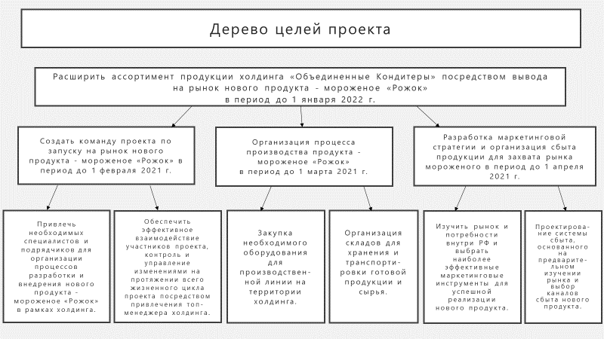

**Figure 1 - Goal tree**

Paragraph 1.3 Definition of the scope of work

In the second section of the course project, it is necessary:

* Determine the scope of work (requirements, product description);
* Generate content (project and product description);
* Develop a hierarchical structure of work (ISR).

**Determining the scope of work (requirements, product description)**

Determining the scope of work can be divided into three main stages:

* Requirements collection is the process of identifying and documenting the needs of project stakeholders to achieve project goals.
* Content definition is the process of developing a detailed description of the project and product.
* Creating a Hierarchical Work Structure (ISR) is the process of dividing project results and project work into smaller elements that are easier to manage.

Requirements collection - is the process of identifying and documenting the requirements of project stakeholders to achieve project objectives. The success of the project is directly affected by the thoroughness of collecting and managing project and product requirements. Requirements include quantified and documented needs and expectations of the sponsor, the customer and other stakeholders of the project. These requirements should be identified, analyzed and recorded in sufficient detail so that they can be measured after the start of the project. Requirements collection is the definition of customer expectations and their management.

Requirements collection process:

1. Identification of participants and stakeholders

2. Identification of requirements

3. Review, structuring, categorization of requirements, including the definition of individual and general requirements

4. Analysis and ranking of requirements

5. Formation of documents and specifications of requirements

6. Coordination and approval of requirements

To collect requirements, it is important to choose the appropriate tool or method.

Tools and methods for collecting requirements:

* Interview;
* Focus groups;
* Seminars with moderator participation;
* Methods of group creativity: Brainstorming; Method of nominal groups; Construction of associative maps; Similarity diagram; Analysis of solutions based on a variety of criteria;
* Methods of group decision-making: Unanimity (Delphi method); Majority; Relative majority; Dictatorship;
* Questionnaires and surveys;
* Observations;
* Prototypes;
* Benchmarking;
* Contextual charts;
* Document analysis.

The result of collecting requirements is:

1. Requirements documentation describes how individual requirements meet the business needs of the project. The requirements must be unambiguous (measurable and verifiable), traceable, complete, consistent, and acceptable to key stakeholders.
2. The requirements tracking matrix is a table linking product requirements, starting from their creation and ending with the provision of deliverables corresponding to them. Applying a requirements tracking matrix helps make sure that each requirement adds business value by linking the requirement to the goals of the organization and the project.

**Content definition (project and product description)**

Content definition is the process of developing a detailed description of the project and product. The preparation of a detailed description of the project content is extremely important for the success of the project and is based on the main results, assumptions and limitations documented during the initiation of the project. The content of the project is determined during planning and described in more detail as information about the project becomes available.

The key benefit of this process is that it describes the boundaries of a product, service or result by determining which of the collected requirements will be included in the content of the project and which are excluded from it.

Tools and methods that are used to determine the content of the project:

* Expert assessment
* Product Analysis
* Search for alternatives
* Seminars with moderator participation

After determining the content, we get a summary of the main deliverables, assumptions and limitations.

Basic elements:

* Description of the product content - the characteristics of the product, service or result described in the project charter or in the requirements documentation.
* Acceptance criteria - a set of conditions that must be met before the delivered results are accepted.
* Deliverable result - any unique and verifiable product, result, or ability to provide a service that needs to be produced to complete a process, phase, or project.
* Exceptions from the project - what is outside the content of the project helps to manage the expectations of stakeholders
* Limitations - internal or external limits or limiting conditions of the project related to its content that affect the execution of the project.
* Assumptions are a factor in the planning process that is considered true, real or certain without providing evidence and without demonstration. It also describes the potential impact of these factors in case they turn out to be erroneous.

**Creating a hierarchical structure of work (HSW)**

Creating a hierarchical Work structure (HSW) is the process of dividing project results and project work into smaller elements that are easier to manage. At each lower level, the HSW presents an increasingly detailed description of the work on the project. The HSW organizes and determines the overall content of the project and presents the works specified in the current approved description of the project content when developing a hierarchical structure of work, it is necessary to adhere to the following requirements:

1) Each new level in the HSW adds more detailed elements, each of the elements is associated with a more general element located a level higher.

At any of the levels, only one "parent" (total) element corresponds to a group of "child" (detailed) elements. This is the fundamental rule that ensures the correctness of the summation of the cost and generalization of information about the work during the transition from one level to another;

2) Each element of the HSW should act as an aggregated result ("sum", "total") of all subordinate "child" elements into which it is decomposed (split).

The "100% rule" means that the detailed work of each subsequent level of partitioning must fully ensure that the work is completed and the result of the task of a higher level is obtained.;

3) Work packages and jobs must be unique and different from other work packages.

Duplication of work is unacceptable;

4) The parent element must have more than one child element.

This rule avoids an excess of levels and provides a structure suitable for performing aggregation operations.

5) The ISR should be complete, but not redundant.

All the work of the HSW is the work that will be performed during the project. Works not included in the ISR are not included in the project and are not performed;

6) The section of the ISR at any level of detail represents a complete list of works of the project of a certain level of enlargement (in accordance with the level at which the section was made).

Each next level represents the next level of detail of project operations.

7) The development of the HSW is carried out by the method of sequential partitioning "from top to bottom", but can be supplemented by the "bottom-up" method.

Standard technological sequences of works can be used for standard project works;

8) The division of work should be carried out until elementary results and works of the project are determined for each branch of the structure, ensuring the achievement of all the goals of the project.

For example

Construction of the HSW scheme, on the example of the project "non-melting chocolate"

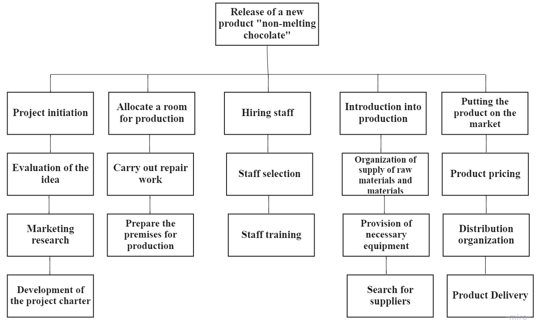

Figure 2 - HSW of the project

Paragraph 2.1. Analysis of stakeholders and development of a plan to involve them in the project

In the fourth section of the course project, it is necessary:

* conduct an analysis of stakeholders;
* create a register of interested parties;
* to analyze the impact of project stakeholders;
* Create an impact matrix to evaluate project stakeholders.

**Stakeholder analysis**

To conduct an analysis of stakeholders, it is necessary to implement three stages:

1. Identify all potential stakeholders in the project and information about their roles, level of competence, expectations, and requirements for the project product and the degree of impact on the project.

Internal key stakeholders are easily identified based on the organizational structure adopted for the implementation of the project. Other interested parties are determined through the process of interviewing decision makers in the organization of the Customer and the Contractor.

Project stakeholders are individuals and organizations that are actively involved in the project or whose interests may be affected as a result of the project. The register of Interested Parties records the circle of these persons and organizations and may include the following information:

- Surname, first name, patronymic of the person (name of the organization);

- Position of the person;

- Location;

- Role in the project;

- contact information;

- Basic requirements;

- Basic expectations;

- The level of potential impact on the project;

1. Analyze the potential impact or support that a stakeholder can provide, classify and prioritize stakeholders and develop an appropriate interaction strategy for the most efficient use of the Project Manager's time resources.
2. Evaluate how a particular stakeholder will react to possible scenarios of the project progress, in order to plan actions aimed at activating its support or mitigating the negative impact.

**Register of stakeholders**

**For example**

Table 1 - Register of project stakeholders

| **Project stakeholders** | | | | |
| --- | --- | --- | --- | --- |
| Full name/  position/  group | Role in the project | Contact information | Requirements | Influence |
| -/young people under 20 years old/visitors of confectionery shops | Consumers | +79250000001 | High-quality product, eco-friendly materials, no fat substitutes in the composition, justification of the name (really non-melting chocolate) | Very strong |
| Kondratiev K.O./head of the tax inspectorate/ supervising the implementation of laws | Interested party (in timely payment of taxes) | +79250000002 | Compliance with production standards, payment of taxes, transparency in doing business | strong |
| Kasimova E.P./General Director of Event LLC/contractor | Resource Provider | +79250000003 | Providing a place to work, providing the necessary resources | Strong |
| Platonov P.O./RTR journalist/information and news | Project progress coverage | +79250000004 | High-quality new product press conference | Moderate |
| Bulganina N.A./Head of the regional Department of Environmental Control /controlling | Controlling | +79250000005 | The use of eco-friendly materials in the production, the creation of additional jobs | Moderate |
| Coco S./Creative Director of LLC "Chocolate"/ competitor | Criticism, opposition | +79250000006 | Conducting fair competition, the hope that the product will not be in demand | Weak |
| Lagutin N.A./Deputy.Director's gene - Chief technologist/assistance in project implementation | Top management of the parent company | +79250000007 | Provision of equipment and resources within the company. Compliance with the established security measures. | Strong |
| Litvin I.P./RP/Project management team | Project Manager | +79250000008 | Compliance with deadlines, quality and budget of the project | Strong |
| Mamontov P.V./Deputy General Director for Development/curator | Project curator | +79250000009 | Not exceeding the budget, proper documentation, receiving benefits from the product | Strong |
| Ivanov I.I./master of food production/project team | Project team member | +79250000010 | Successful implementation of "non-melting chocolate", awards based on the results of the project, the basis for subsequent projects | Average |

**Analysis of the impact of project stakeholders**

**For example**

Table 2 - Analysis of the impact of project stakeholders

|  | Project stakeholders/stakeholder groups | | | |
| --- | --- | --- | --- | --- |
| code | Surname, initials/group | Role in the project | Authority | Interest |
| A | Consumers | Consumers | Minor | Average |
| B | Kondratiev K.O. | Controlling state agencies | Significant | Low |
| C | Kasimova E.P. | Resource Provider | Insignificant | Strong |
| D | Platonov P.O. | Project progress coverage | Moderate | Average |
| E | Bulganina N.A. | Controlling | Insignificant | Low |
| F | Coco Ch. | Criticism, opposition | Insignificant | Average |
| G | Lagutin N.A. | Top management | Significant | Strong |
| H | Litvin I.P. | Project Manager | Significant | Tall |
| I | Mamontov P.V. | Project curator | Significant | Tall |
| J | Ivanov I.I. | Project team member | Moderate | Tall |

**Impact matrix for evaluating project stakeholders**

**For example**

Influence Matrix

|  |  |  |  |  |  |  |  |  |
| --- | --- | --- | --- | --- | --- | --- | --- | --- |
| Significant |  |  |  |  |  |  |  |  |
| ***/*** | ***/*** |  |  | ***///*** | ***/*** |  | ***/*** |
| **Authority** |  |  |  |  |  |  |  |  |
|  | ***/*** |  | ***/*** |  |  |  | ***/*** |
|  |  |  |  |  |  |  |  |
|  | ***/*** |  |  | ***///*** |  |  |  |
| Insignificant |  | ***/*** |  | ***/*** |  |  |  |  |
|  |  |  |  |  | ***/*** |  |  |

Figure 3 - Impact matrix for evaluating project stakeholders

Paragraph 2.2 Project risk assessment (identification, analysis, development of response measures)

In the fifth section of the course project, it is necessary:

* create a SWOT analysis matrix;
* conduct a quantitative risk analysis of the project (risk measurement);
* Make a plan to minimize the risks of the project.

Before proceeding to the risk management stage, it is necessary to identify them. The following analysis tools should be applied in order: Ishikawa diagram, identification of the root cause.

**Ishikawa Diagram**

The Ishikawa diagram, aka "fishbone" and "causal relationship diagram" helps to categorize and visualize the potential causes of the problem. The diagram was invented by Japanese professor Kaoru Ishikawa back in 1950-1951, for a long time it was used to identify the causes of defects and deviations in industry and eventually became a popular quality management tool.

And project and product teams began to use the diagram, including for working with risks.

The Ishikawa diagram refers to a type of cause-and-effect diagrams, with the help of which factors affecting the outcome of the project are identified. So, the possible result is indicated on the right, and on the left, on each branch of the diagram, the factors affecting it are indicated, and each branch represents a separate type of influencing factors.

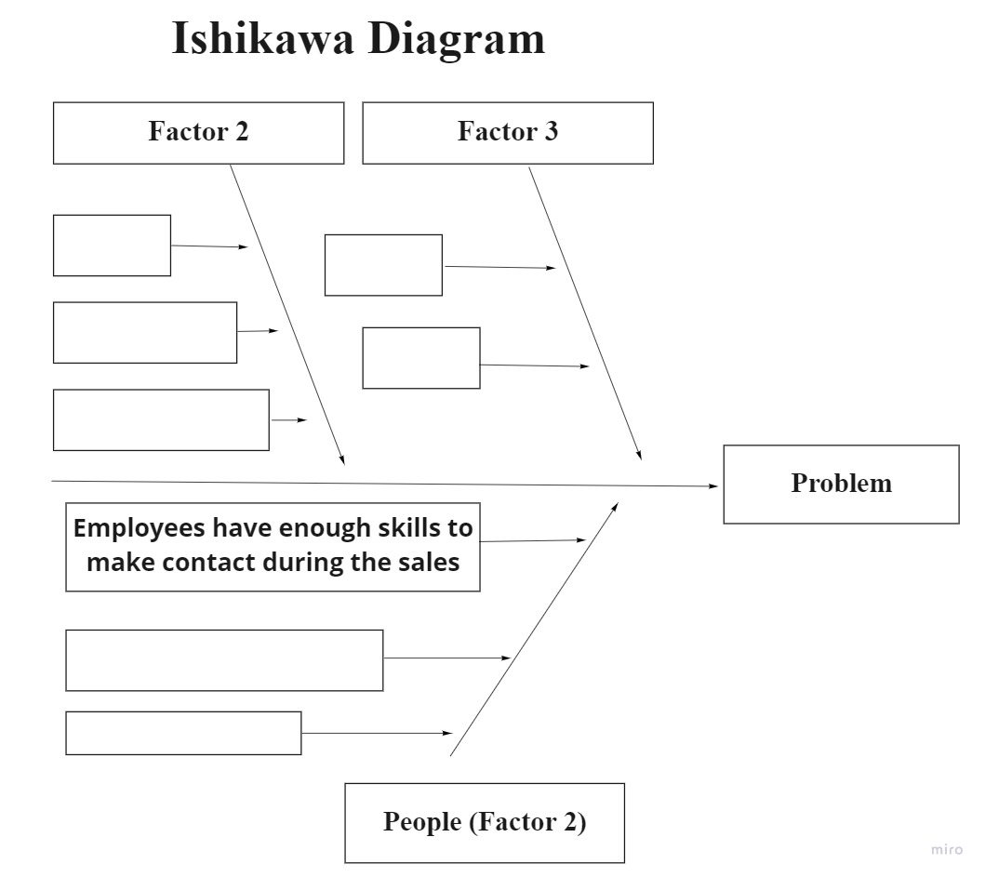

Figure 4 - Ishikawa Diagram

**How to build an Ishikawa Diagram?**

**Assemble a team**

Assemble a team and, if necessary, other stakeholders. Explain to them what's going on.

**Determine what you want at the output**

Formulate the task that you want to solve - for example, consider the reasons why the timing of the launch of the project may be disrupted. Transfer this formulation to the right side of the board or sheet — this will be the head of the fish.

**Formulate groups of risk sources**

Combine risk sources into large groups. For example, if you are developing a mobile application, your sources of risk may be related to users, stores, team, and so on.

**Go to the details**

Supplement each large group with specific sources – the "bones" of fish.

Use the resulting diagram to identify risks.

Identification of the root cause. This is the identification of the most significant causes of project risks. This makes it possible to give more precise definitions of risks and group risks according to the reasons that cause them. Risk response can be effective only when it is aimed at eliminating the root cause of the risk. For clarity, it is worth writing everything in the table below:

Table 4 - Ranking of project risks

|  |  |
| --- | --- |
| **Risk** | **Group** |
| The increase in the cost of purchasing a product | Commercial |
| Reduction of planned output volumes | Production |
| … | … |

After the analysis, it is necessary to calculate the risks by groups and determine which groups will be crucial.

**Quantitative risk analysis (risk measurement)**

Quantitative analysis of project risks is carried out on the basis of mathematical models of decision-making and project behavior, the main of which are:

* Stochastic (Probabilistic)
* Linguistic (Descriptive)
* Non-stochastic (gaming, behavioral)

For quantitative analysis in our project, we will use the following methods:

Analysis of project development scenarios - this method involves the development of several project development options and their comparative evaluation.

Three types of scenarios are calculated:

* Pessimistic
* Optimistic
* Most likely

The method of building decision trees of the project involves a step-by-step branching of the implementation process with an assessment of risks, costs, damages, benefits.

**Project risk minimization plan**

Preparation of a project risk minimization plan is carried out at the stage of preparation of the project plan and control documents.

There are 3 groups of methods to minimize project risks.

1. Diversification, or risk distribution– is the distribution of an enterprise's efforts between activities whose results are not directly related to each other.

This method allows you to share risks between project participants, which is an effective way to reduce them.

1. Reserving funds to cover unforeseen expenses.

This method is a way of dealing with risk, providing for the establishment of a ratio between potential risks affecting the cost of the project and the amount of expenses necessary to overcome failures in its implementation.

1. Risk insurance

If the project participants are unable to ensure its implementation upon the occurrence of a risk event, it is necessary to carry out risk insurance on their own.

Risk insurance is essentially the transfer of certain risks to an insurance company.

For example

Company - United Confectioners

New product: introduction of a new heat-resistant chocolate bar to developed markets

Table 5 - Results of the SWOT analysis of the project

| **S-strengths** | **W- weaknesses** |
| --- | --- |
| Effective business structure of the company.  High-quality distribution system.  Wide representation in sales channels.  Market leadership. | Problems with TT (traditional trade), complex distribution and difficult to negotiate. |
| **О- opportunities** | **T-threats** |
| Patenting for a heat-resistant chocolate bar, which will open up new sales markets. | Price pressure from the main competitors: Nestle, Mars.  Competitors have sufficient resources and can patent a heat-resistant chocolate bar before us. |

Identification of the root cause

Table 6 - Breakdown of risks into groups

|  |  |
| --- | --- |
| **Risk** | **Group** |
| High level of product defects associated with the novelty of the technology | Production |
| Equipment failure (breakdown) | Production |
| Increase in the cost of purchasing products | Commercial |
| Increase in production costs due to changes in production technology | Production |
| Change in the exchange rate, which affects the purchase of imported components for products and enterprises and export prices | Financial |
| Decrease in the size of product sales due to market conditions | Commercial |

In total, we have 3 production risks, 2 commercial and 1 financial. Therefore, it is necessary to focus our efforts on preventing, managing and minimizing production risks and, if possible, commercial risks.

Next, we proceed to a quantitative analysis of the risks of the project.

Analysis of project development scenarios

Scenario analysis can be recorded in any visual format. But for convenience, we will depict it in the table. Let's assume that the company invests a net profit of 1,000 million rubles in a new project (which is about half of the company's profit for 2014). Given the external competition from other companies and the emerging markets themselves, we can establish the probabilities of all 3 scenarios.

Table 7 - Project development scenarios

|  |  |  |  |
| --- | --- | --- | --- |
| **Scenarios** | **Probability** | **BDD, million rubles** | **BDD, million rubles, taking into account the probability** |
| Optimistic | 0,1 | 1000 | 100 |
| most likely | 0,5 | 1000 | 500 |
| Pessimistic | 0,4 | 1000 | 400 |

**Risk minimization**

**100 million - Marketing Research**

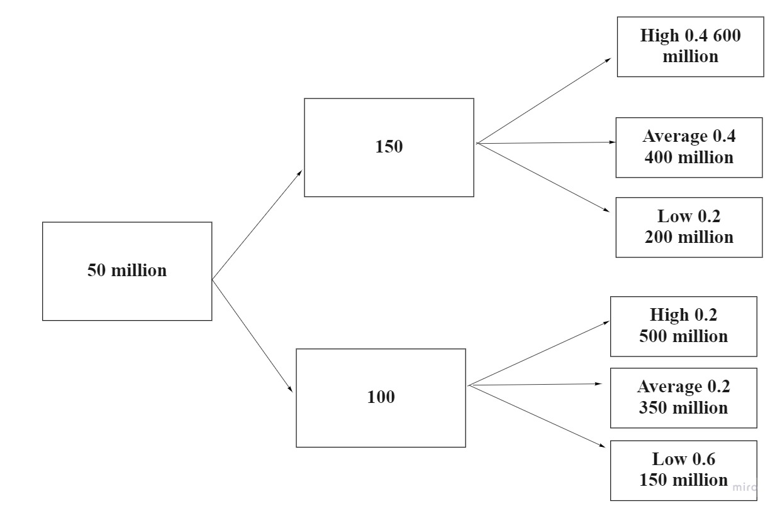

Figure 4 - Quantitative risk analysis

Without marketing research – 50 million

3 groups of methods to minimize project risks

1. Distribute risks, for example, transfer more financial resources to the production sector. Thus, we will reduce the number of production risks and increase the number of financial risks.
2. Creation of a financial security zone and a financial "cushion" for the project. For example, 20% can be allocated for an increase in direct production costs, 10% for the costs of foreign performers of work on our project and an increase in the reserve of funds for interest on loans, if any.
3. Complete full insurance for this investment project.

Thus, a comprehensive system of identification, management and risk minimization will allow us to increase the success of this project.

Paragraph 2.3 Evaluation of project performance indicators

In the sixth section of the course project, it is necessary to calculate

* NPV of the project (net present value of the project);
* IRR - internal rate of return;
* The payback period of the project.

Evaluating the effectiveness of a new launch will help to assess how profitable the project is for the company, what profitability it will bring to it, whether it will pay off the investments made and after what period, and will also help to compare this launch with similar launches in the same company, segment and even industry.

The key performance indicators of the project are:

1. 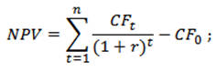NPV is the net present (to date) cost of the project.

To calculate this indicator, we will follow the following methodology:

* 1. Let's estimate the cash flows from the project, that is, the initial investment (outflow) and the expected receipts (inflows) of funds.
  2. Determine the discount rate through the weighted average cost of capital (WACC);
  3. We will discount the inflows at the discount rate and add them up;
  4. Deduct from the amount of discounted inflows - our initial investment.

If the NPV indicator is less than zero, then most likely the project is not profitable for investors and developers at the moment.

1. IRR is the internal rate of return, one of the main indicators used in assessing the attractiveness of an investment project.



To calculate this indicator, we will follow the following methodology:

1. Calculate the NPV according to the previous method and equate this indicator to zero
2. Manually (through a mathematical equation) or using the MS Excel formula package, we will find the IRR
3. Compare the IRR with the WACC (discount rate). If IRR > WACC, then the project will be profitable and it is worth accepting.
4. Payback Period (Eng. Pay-Back Period) — the period of time required for the income generated by investments to cover the investment costs.

To calculate this indicator, we will follow the following methodology:

* 1. Calculate discounted cash flows for each year
  2. We will sum up the cash flows until they exceed the initial investment - the duration during which we receive these flows will be the payback period.

**For example**

1. **Consider a sales plan**

Additional information:

Automatic line AS 275 "One-Shot" molding of chocolate, jelly, fondant products

The average productivity of the equipment is 1400 kg of "non-melting chocolate" per hour.

* The power of the equipment is loaded at 100%.
* The number of hours in a shift (working day) is 8 hours.
* The number of working days in a year is 360 days.

Table 8 - Planning of sales of the product "Non-melting chocolate"

|  |  |  |
| --- | --- | --- |
| Name | Weight | Number of units. per year |
| Non-melting chocolate | 100 gr. | 40 320 000 |

**2. We make an estimate of costs**

Food industry organizations, as a rule, use a typical cost grouping, which contains the following items:

1. raw materials, basic materials and semi-finished products;
2. returnable waste (deducted);
3. auxiliary materials;
4. fuel and energy for technological purposes;
5. wages of the main production workers;
6. deductions for social needs;
7. costs of preparation and development of production;
8. operating costs of production machinery and equipment;
9. general production (shop) expenses;
10. general economic expenses;
11. Other production costs.

**Total: production cost of production.**

1. commercial expenses (selling expenses);

**Total: total cost of production.**

To manage the cost of production, the classification of direct and indirect costs should be used. Direct costs are the costs directly related to the production of a certain type of product, so they are directly related to its cost. Direct costs include materials and raw materials, labor costs of the main production personnel, and the amount of accrued depreciation of production equipment employed in production. Indirect expenses are understood as expenses that cannot be directly attributed to the cost of manufactured products. They are subject to indirect distribution, in proportion to any base.

2.1 Estimation of raw materials and basic materials costs

Table 9 - Planning of expenses for raw materials and materials per unit of goods (non-melting chocolate)

|  |  |  |  |  |  |
| --- | --- | --- | --- | --- | --- |
| **Ingredients** | | **Quantity, gram** | **Price, per 1 kg** | **Price, per 1 gram** | **Cost, rub.** |
| **composition of the filling** | | | | | |
| 1 | chocolate 50% cocoa callebout | 34 | 340 | 0,34 | 11,56 |
| 2 | cream 35% petmol | 11 | 280 | 0,28 | 3,08 |
| 3 | candied orange | 1 | 100 | 0,1 | 0,10 |
| 4 | butter | 9 | 274 | 0,274 | 2,47 |
| 5 | confectionery mixture | 5 | 470 | 0,47 | 2,35 |
| **Body composition** | | | | | |
| 6 | chocolate 70% callebout | 40 | 350 | 0,35 | 14,00 |
| **Total raw materials** | | **100** | **х** | **х** | **33,56** |
| 7 | packaging per unit. | х | х | х | 5,00 |
| **Total** | | | | | **38,56** |

Table 10 - Planning of expenses for raw materials and supplies for 1 year

|  |  |  |  |
| --- | --- | --- | --- |
| **Expenditure** | **Number of units per year** | **Total per unit, rub.** | **The amount for the year, rub.** |
| Raw materials, basic materials | 40 320 000 | 38,56 | 1 554 739 200 |

**2.2. Estimation of equipment costs**

The capital costs of production include the costs of purchasing equipment. There are no plans to purchase premises for production, as there are free areas.

Table 11 - Calculation of the initial cost of equipment

|  |  |  |
| --- | --- | --- |
| Name | Price including VAT 20% | Price without VAT, RUB. |
| Automatic line AS 275 "One-Shot" molding of chocolate, jelly, fondant products | 7 100 000 rub .[1] | 5916667 |
| Transportation services | 12 000 rub . | 10000 |
| Equipment installation and adjustment services | 200 000 rub . | 166667 |
| **Total initial cost of equipment** | | **6093333** |

The costs of installation and commissioning of the equipment are included in its cost. Gradually, in the course of work, the equipment becomes obsolete and physically wears out - therefore, it is necessary to create a depreciation fund, thereby transferring the initial cost of the equipment for the entire period of its operation.

According to the technical documentation, the useful life of the automatic line AC 275 "One-Shot" is 10 years.

Table 12 - Calculation of depreciation of the automatic line AC 275 "One-Shot"

|  |  |  |  |  |  |  |  |  |  |  |
| --- | --- | --- | --- | --- | --- | --- | --- | --- | --- | --- |
| Period (year) | 2020 | 2021 | 2022 | 2023 | 2024 | 2025 | 2026 | 2027 | 2028 | 2029 |
| Initial cost of fixed assets | 6093333 |  | | | | | | | | |
| Depreciation (linear) | 609333 | 609333 | 609333 | 609333 | 609333 | 609333 | 609333 | 609333 | 609333 | 609333 |
| Book value (residual) at the end of the period | 5484000 | 4874666 | 4265333 | 3656000 | 3046667 | 2437333 | 1828000 | 1218667 | 609333 | 0 |
| Accumulated depreciation | 609333 | 1218667 | 1828000 | 2437333 | 3046667 | 3656000 | 4265333 | 4874666 | 5484000 | 6093333 |

**2.3. Estimation of fuel and energy costs for technological purposes**

**Power consumption of the automatic line AC 275 "One-Shot":**

1. TEN heater forms - 4 kW;

2. servomotors – 1 kW;

3. TEN heater jacket - 1.5 kW;

4. Vibrators - 2 × 180 Watts;

5. Conveyors – 3 × 250 watts;

6. Fans – 3 × 300 watts;

7. Refrigerator compressor – 9 kW.

**Total: Electricity - 18 kW.**

Table 13 - Calculation of fuel and energy costs for technological purposes

|  |  |  |  |  |  |
| --- | --- | --- | --- | --- | --- |
| Name | Unit of measurement | Electric energy consumption per day (shift - 8 hours) | Price/tariff without VAT | Total per shift | Total  for the year  (360 working days - shifts), in rubles. |
|  |  |  |  |  |  |
| Electricity | 18 кВт в час | 144 | 6,21[2] | 894,24 | 321926 |

* 1. Assessment of the amount of wages of the main production workers and social contributions

Table 14 - Calculation of wages of the main production workers and deductions for social needs

|  |  |  |  |  |  |
| --- | --- | --- | --- | --- | --- |
| Post | Number, people. | Rate (thousand per month) | Labor costs for the year | Insurance premiums (30%) | Total wage fund |
| Production Line Controller | 2 | 50 000 | 720000 | 216000 | 936000 |
| Packer | 2 | 30 000 | 1200000 | 360000 | 1560000 |
| Total | | х | 1 920 000 | 576 000 | 1. 496 000 |

General production (shop) expenses

Table 15 - Calculation of general production (shop) expenses

|  |  |  |  |
| --- | --- | --- | --- |
| Expenses | In just a year, without VAT. | The share of expenses attributable to the production of non - melting chocolate | Total expenses |
| Utility payments of the production shop | 2 000 000 | 5% | 100 000 |
| Workshop rent | 10 000 000 | 5% | 500 000 |
| Итого | | | 1. 0 |

General economic expenses

Table 16 - Distribution of general economic expenses attributable to "Non-melting chocolate"

|  |  |  |  |
| --- | --- | --- | --- |
| Expenses | In just one year, without VAT. | The share of expenses attributable to the production of "Non-melting chocolate" | Total expenses |
| Utility bills (premises of management personnel) | 800 000 | 5% | 40 000 |
| Rental of premises (management personnel) | 2 000 000 | 5% | 100 000 |
| Management Personnel Remuneration Fund | 50 000 000 | 5% | 2 500 000 |
| Total | | | 2 640 000 |

3. Development of a plan for the costs of production and sale of products for 1 year

To calculate the total cost of production, we need to determine the totality of all manufacturing costs.

Table 17 - Calculation of expenses for the production of "Non-melting chocolate"

|  |  |
| --- | --- |
| **Items of expenditure** | **Amount, rub.** |
| Raw materials, basic materials | 1 554 739 200 |
| Equipment (depreciation) | 609 333 |
| Fuel and energy for technological purposes | 321 926 |
| Wages of the main production workers and deductions for social needs | 2 496 000 |
| General production (shop) expenses | 600 000 |
| General economic expenses | 2 640 000 |
| **Total expenses** | **1 561 406 459** |

The sales plan for "Non-melting chocolate" is 40,320,000 units per year.

Table 18 - Calculation of expenses for the production of "Non-melting chocolate" per unit of product

|  |  |  |  |
| --- | --- | --- | --- |
| **Items of expenditure** |  |  | Expenses per unit, rub. |
| 1. Raw materials, basic materials |  |  | **38,56** |
| 2. Equipment (depreciation ) |  |  | 0,02 |
| 3. Fuel and energy for technological purposes |  |  | 0,01 |
| 4. Wages of the main production workers and deductions for social needs |  |  | 0,06 |
| 5. General production (shop) expenses |  |  | 0,01 |
| 6. General economic expenses |  |  | 0,07 |
| **Total production cost of units.** | |  | **38,73** |

4. Sales profit plan

The margin is the amount added to the cost price (if there is own production). The margin is determined in accordance with market conditions, quality and consumer properties of goods. It should cover the costs of circulation, the amount of taxes.

The sale price is the amount that the customer pays when buying the product.

The formula for calculating the sale price, knowing the margin as a percentage and the cost price:

|  |  |  |
| --- | --- | --- |
| Sale price = | Cost price | * (Extra charge (%) + 100) |
| 100 |

Table 19 - Calculation of the sale price of "Non-melting chocolate"

|  |  |  |  |  |  |
| --- | --- | --- | --- | --- | --- |
| **Name** | **The total cost of units. rub.** | **Extra charge,%** | **The sale price is RUB, without VAT.** | **Number of units. per year.** | **Revenue for the year. (without VAT)** |
| Non-melting chocolate | 38,73 | 40% | 54,22 | 40 320 000 | 2 186 150 400 |

Table 20 - Calculation of profit from sales for 2020

|  |  |  |
| --- | --- | --- |
| **№** | **Indicator** | **Amount, rub.** |
|
| 1 | Revenue | 2 186 150 400 |
| 2 | Cost price | 1 558 766 459 |
| 3 | Gross profit | 627 383 941 |
| 4 | Commercial expenses | 0 |
| 5 | Management expenses | 2 640 000 |
| **Profit from sales** | | **624 743 941** |

5. Calculation of the break-even point

Break-even point (break-even point– BEP) is the volume of sales at which the entrepreneur's profit is zero. Profit is the difference between incomes (TR- total revenue) and expenses (TC– total cost). The break-even point is measured in physical or monetary terms. This indicator helps to determine how many products need to be sold (work to be performed, service to be rendered) in order to work to zero.

Variable costs are the costs that appear during the production of each new unit of production (service rendered).

Fixed costs are costs that are practically unchanged throughout the entire billing period.

In order to calculate the break-even point in kind, it is necessary to use the following indicators:

* + 1. Fixed volume costs (FC- fixed cost);
    2. Unit price of goods (services, work) (P- price);
    3. Variable unit costs (AVC- average variable cost).

You can calculate the break-even point in kind using the following formula:

BEP= FC/ (P-AVC)

Table 21 - Grouping of costs into constants and variables

|  |  |  |
| --- | --- | --- |
| **Items of expenditure** | **Expenses** | **Amount, rub.** |
| 1. Raw materials, basic materials | Variables | 1 554 739 200 |
| 2. Equipment (depreciation ) | Permanent | 6 667 259 |
| Fuel and energy for technological purposes |
| Wages of the main production workers and deductions for social needs |
| General production (shop) expenses |
| General economic expenses |
| **Total expenses** |  | **1 561 406 459** |

Calculation of the break-even point:

a. Fixed volume costs (FC- fixed cost) = 6,667,259 rubles

b. Unit price of goods (services, works) (P– price) = 54.22 rubles

c. Variable unit costs (AVC- average variable cost) = 1 554 739 200/40 320 000 = 38,56 rub.

Break-even Point (BEP) = 6 667 259/ (54,22 – 38,56)= 452 451 ed.

Thus, the minimum volume of sales of "Non-melting chocolate" should be 452,451 units. Exceeding this volume of production and sales will lead to profit.

Paragraph 3.1 Development of a project management plan

In the seventh section of the course project, it is necessary:

* make a basic project plan (calendar plan);
* make a project management plan by milestones;
* Create a network schedule for the project.

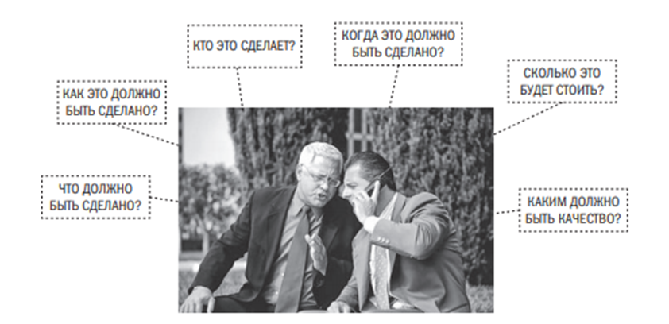The definition of planning is reduced to answers to a chain of questions: who, what, when, why, where, for how long, as, for example, in Figure 1

**Figure 5 - Planning**

In order to properly plan a project, it is necessary to pay attention to three aspects: strategy, tactics and logistics.

Minimum components are also needed to draw up a project plan.

1. Documentary formulation of problems
2. the mission of the project
3. project objectives
4. requirements for the execution of work on the project (include a list of results that is created during the project)
5. exit criteria from the next phase (indicated indicators of completion of a specific phase of the project)
6. standards and certifications that the project must meet
7. hierarchical structure of works
8. schedules for the main stages of the project
9. necessary resources (people, equipment, materials, premises)
10. control system
11. main performers and participants
12. risk zones and its overcoming

When the plan is prepared, it must be submitted to all interested parties for approval and signing.

Also, unforeseen difficulties always arise, and therefore it is necessary to make changes to the project plan.

In addition to these stages of creating a plan, it is worth considering the recommendations:

* + Plan the planning. It's about planning an event in advance to create a plan so that there is no disruption of the event or turning into a spontaneous meeting.
  + The people who will execute the plan should participate in its development. Otherwise, at the stage of project execution, participants may appear who do not feel a sense of responsibility for the implementation of this plan.
  + Be ready for rescheduling.
  + Risk analysis at all stages of the life cycle.
  + define the goals of the project and formulate the problem of its implementation
  + With the help of the ISR, it is necessary to divide the work into small processes.

**Basic project plan**

For example

Coverage of the basic planning methodology. Practical development of basic planning on the example of JSC "United Confectioners Holding Company"

The Basic project plan (Baseline or Performance Management Baseline) or the basic project execution plan is a summary of the volume, timing and cost of the project agreed at the planning stage, on the basis of which its progress is monitored during the project execution.

One of the basic planning tools is the Basic Project Calendar Plan. The basic project schedule is an agreed project schedule, including the start and end dates of each task.

Why you need a basic project plan. A basic project plan is needed:

* At the start - for unambiguous coordination of the scope, cost and duration of the project with all interested parties.
* During the project - to monitor the "health" of the project. If there is a deviation from the basic plan in any of the directions, the RM understands that something has gone wrong and can take some actions to get the project back on track.

Table 9 - Variant of the calendar plan

| Process name | Start of execution | End of execution |
| --- | --- | --- |
| Survey of consumers in chain stores on favorite sweets, what the consumer likes; | 01.07.2020 | 01.08.2020 |
| Competitor analysis, market availability from other candy manufacturers | 01.07.2020 | 01.08.2020 |
| The choice of products that are already popular on the market - a new product for production based on the results of market analysis and consumer taste preferences | 02.08.2020 | 01.09.2020 |
| Development of a technological process for creating a new sweet (product) | 02.09.2020 | 01.10.2020 |
| Purchase of raw materials from subsidiaries to launch the production of the first tasting products | 20.09.2020 | 02.10.2020 |
| Creation of the first tasting products for testing in a focus group | 03.10.2020 | 31.10.2020 |
| According to the results of testing - the choice of the technological process for the standard (decided on the final product) | 01.11.2020 | 05.11.2020 |
| Obtaining a quality certificate for the selected final product (GOST) | 06.11.2020 | 15.11.2020 |
| Establishing the process of mass production of the product | 16.11.2020 | 05.12.2020 |
| Shipment of the first batch of the product to customers | 05.12.2020 | 10.12.2020 |
| Develop a marketing strategy for a new line (finished product) | 15.11.2020 | 25.11.2020 |
| To establish sales channels for the new line (chain stores, wholesale bases, online stores, large retail enterprises) | 15.11.2020 | 10.12.2020 |
| Mass media (within the Internet resource) and media promotion | 25.11.2020 | 10.12.2020 |

Project management plan by milestones

**For example**

A plan for milestones on the example of JSC "United Confectioners Holding Company".

As a result of the construction of the earlier ISR and the Structural scheme of the project organization for the company JSC "Holding Company "United Confectioners" - it is possible to coordinate with the customer the main stages of the project. The so-called milestones.

By milestone we mean an event or a specific date(s) during the implementation of our project. Project management experts Eric Larsen and Clifford Gray give the following definition: a milestone is a significant event in a project that occurs at a certain point in time. The milestone graph uses the results to identify the main work segments and the end date. Milestones should be natural, important control points in the project and easily recognizable.

By milestones, we can track the status of completion/completion of certain works of our project. Within the framework of a project, managers use the definition of milestones in order to identify important results during the implementation of the project. Thus, the manager can create a sequence of their previously designated milestones, which will be the plan for milestones, which will reflect the main stages of the project by dates and effects that we need to get.

Thanks to the milestones plan, the project manager will be able to determine the main reference points for working with the company JSC Holding Company United Confectioners. Thus, by managing the company, we can manage the deadlines for the completion of work, the result of each of their work and, thanks to these reference points, reach the effective completion of the project.

During the placement of milestones, pay attention to the following parameters:

* Frequency. As a project manager, you may be tempted to abuse milestones, using them as a motivation tool to support the team on the path to success. Don't fall into the trap of starting to mark the completion of each task as a milestone. On the other hand, do not go to extremes, ignoring significant events as milestones, in particular, at the junctions of the critical path. A good compromise would be to consistently place milestones on important results.
* Distribution over time. The milestones of the project, located too far from each other, will not allow you to benefit from the inspiration of a team that has realized its main achievements. However, when milestones are located too close to each other, they quickly lose their distinctness. Try to place milestones at intervals not exceeding two weeks in projects with a duration of several months.
* Control. Milestones should be clearly marked in the project schedule and monitored periodically. Make sure that your milestones have been included in the project plan, calendar, or other program tracking the implementation of the project.
* Reporting. Milestones represent commitments that must be met on time. If the milestone is not completed on time, you need to do it immediately by re-evaluating the resources and determining how well they are allocated to the goals.
* Possibility of errors. It may seem counterintuitive, but you should choose difficult milestones that have a certain percentage of unsuccessful completion.

We propose to consider an example of a plan for milestones on the example of the plan of the company JSC "Holding Company "United Confectioners":

1 milestone. Choosing a new product that is relevant to the market. (From 01.07.2020 to 01.09.2020)

* + a survey of consumers in chain stores on their favorite sweets, what the consumer likes
  + analysis of competitors, availability of the market from other manufacturers of sweets
  + Selection of products that are already popular in the market - a new product for production based on the results of market analysis and consumer taste preferences.

1. Milestone. Production of a new product (from 02.09.2020 to 10.12.2021)
   * Development of a technological process for creating a new sweet (product) / from 02.09.2020 to 01.10.2020/
   * Purchase of raw materials from subsidiaries to launch the production of the first tasting products / 09/20/2020 to 10/22/2020/
   * Creation of the first tasting products for testing at the focus group /03.10.2020 to 31.10.2020/
   * Based on the results of testing - the choice of the technological process for the standard (decided on the final product) / until 05.11.2020/
   * Obtaining a quality certificate for the selected final product (GOST) /06.11.2020 to 15.11.2020/
   * Establishing the process of mass production of the product / until 05.12.2020/
   * Shipment of the first batch of the product to customers /05.12.2020 to 10.12.2020/

3 milestone. Sale of the finished product on the market (from 15.11.2020 to 10.12.2020)

* + develop a marketing strategy for a new line (finished product)
  + establish sales channels for the new line (chain stores, wholesale bases, online stores, large retail enterprises)
  + SMM (within the Internet resource) and media promotion

Thus, based on the presented plan, we can create the following plan for milestones with key dates:

Choosing a new product that is relevant to the market. (From 01.07.2020 to 01.09.2020)

Production of a new product (from 02.09.2020 to 10.12.2021)

Sale of the finished product on the market (from 15.11.2020 to 10.12.2020)

Network graph

Network graph on the example of JSC "United Confectioners Holding Company"

When performing a set of works, it is always possible to identify a number of events, that is, the results of some activity, allowing you to start performing the following works. If a vertex of the graph is assigned to each event, and an oriented edge is assigned to each work, then some graph will be obtained. It will reflect the sequence of individual works and the occurrence of events in a single complex. If you put the time needed to complete the corresponding work over the edges, you will get a network. The image of such a network is called a network graph. The network schedule consists of two types of main elements: works and events.

Of all the events included in the planned process, two specific ones can be distinguished — the event of the beginning of the process, called the initial event, which is assigned a zero number, and the event of the end of the process (the final event), which is assigned the last number. The others events are numbered so that the number of the previous event is less than the number of the next one.

The following method is used to number events. All the works coming out of the event with the number "0" are crossed out, and all the events in which these crossed out works end are viewed. Among those viewed are events that have no works included in them (with the exception of those already crossed out).

Then all the works coming out of the events of the first rank are crossed out, and among them there are events that do not have incoming works (except those that are crossed out). These are events of the second rank, which are numbered by the following numbers of the natural series. Having done the (k-1) step in this way, they determine the events of the (k-1)-th rank, and looking through the events in which these works end, they select events that do not have any work included in them (except those that are crossed out). These are events of the k-th rank, and they are numbered with consecutive numbers of the natural series, starting with the smallest, not yet used number in the previous numbering at the (k-1)th step.

Table 10 - Precedence matrix

| Process letter | Process name | Predecessor |  |
| --- | --- | --- | --- |
| О | Start of the process | - | 0 |
| А | Development of a technological process for creating a new sweet (product) | О | 41 |
| Б | Purchase of raw materials from subsidiaries to launch the production of the first tasting products | О | 13 |
| В | Creation of the first tasting products for testing in a focus group | А, Б | 28 |
| Г | According to the results of testing - the choice of the technological process for the standard (decided on the final product) | В | 6 |
| Д | Obtaining a quality certificate for the selected final product (GOST) | Г | 10 |
| Е | Establishing the process of mass production of the product | Д | 21 |
| Ж | Shipment of the first batch of the product to customers | Е | 5 |
| З | End of the process | Ж | 0 |

Network graph:

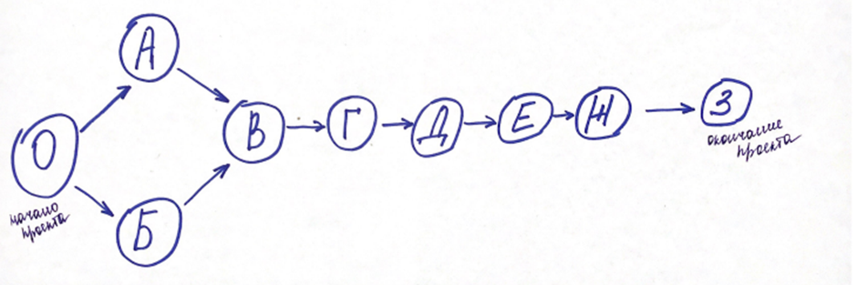

Figure 6 - Network schedule of the project

The network graph contains a finite number of events. Since in the process of crossing out the movement is carried out in the direction of the arrows (works), no previous event can get a number greater than any subsequent one. There will always be at least one event of the appropriate rank, and all events will receive numbers in a finite number of steps.

The work is usually encoded by the numbers of events between which they are enclosed, that is, by a pair (i, j), where i is the number of the preceding event, j is the number of the subsequent event. One or more jobs can enter (exit) the same event. Therefore, the completion of the event depends on the completion of the longest of all the works included in it. The relationship between the works is determined by the fact that the beginning of the subsequent work is due to the end of the previous one. It follows that there are no works that are not connected by beginning and ending with other works through events.

After building the network schedule, the absence of works with the same codes is checked. In the presence of such works, additional events and fictitious works are introduced. In addition, the network graph should contain only one initial event and only one final event.

If these conditions are not met, then it is necessary to add another initial event and connect it with arrows to the existing several initial events, or add another final event to which the arrows lead from several existing final events. The network schedule should not have cycles, that is, paths in which the end of the last job coincides with the beginning of the first job. A network schedule that has at least one cycle cannot be implemented, since none of the work included in such a cycle can ever begin.

Next, it is necessary to calculate the critical path, for this we build a table that reflects all our tasks (N), the number of days that this task goes (t), then it is necessary to calculate the Ph., the early start that comes from the network graph, then, from the reverse, the calculation of the Mon, and the late start. Finally, it is necessary to calculate the time reserve, for this we subtract from the Mon - Ph.

Table 11 - Calculation of the critical path of the project

|  |  |  |  |  |  |  |  |  |  |
| --- | --- | --- | --- | --- | --- | --- | --- | --- | --- |
| N | О | А | Б | В | Г | Д | Е | Ж | З |
| t | 0 | 41 | 13 | 28 | 6 | 10 | 21 | 5 | 0 |
| Рн | 0 | 0 | 0 | 41 | 69 | 75 | 85 | 106 | 111 |
| Пн | 0 | 0 | 28 | 41 | 69 | 75 | 85 | 106 | 111 |
| Time reserve | 0 | 0 | 28 | 0 | 0 | 0 | 0 | 0 | 0 |

The critical path is = O-A-VG-D-E-W-Z

Crete. Path = 111 days.

We propose to leave a reserve for the purchase, since there is a risk of disruption of the purchase terms and to minimize the risk of disruption of the terms, we will not redistribute the reserve. (It is possible to add 5-7 days for the task E - setting up production as part of a safety net).

Paragraph 3.2 Formation of the project calendar plan

In the eighth section of the course project, it is necessary:

Create a project calendar plan in MS Project 2016

**Project calendar plan**

The project schedule is a significant document for the evaluation of the project, which demonstrates the quality of the project development and is a logical and structural document.

General rules for filling out the Project Calendar Plan:

There is a logical sequence of steps for developing a project plan. As a result of creating a calendar plan, a complete project schedule is obtained, taking into account the duration of the work and the resource base necessary to complete the project. Calendar planning, in general, includes several main stages, which makes up a certain planning cycle, among which: planning the project content and building the structure of the decomposition of works, building a sequence of works and a network schedule, drawing up a plan of deadlines, durations, coordinating logical connections of works and displaying them on Gantt charts or tables, determining resource needs (in personnel, mechanisms, materials, etc.) and drawing up a resource use plan, calculating project labor costs and other costs.

In order to make a calendar plan, it is necessary to have agreed ISPs, as usually, the creation of a computer model of a project begins with the development of its Hierarchical Structure of work (HSW). As we know, the hierarchical structure of the work allows you to decompose the work of the project into smaller, visible and manageable parts, more precisely determine the composition and characteristics of the work to be performed.

Using the example of our project, namely the creation of a new product for a confectionery factory, our HSW will consist of the following main parts:

* + Equipment
  + Room
  + Staff
  + Project documentation
  + Supply

**For example**

In order to start working in Project, you need to create a new project. To create a new project, go to the "File" tab on the toolbar, select "Create" and double-click on the "New Project" icon

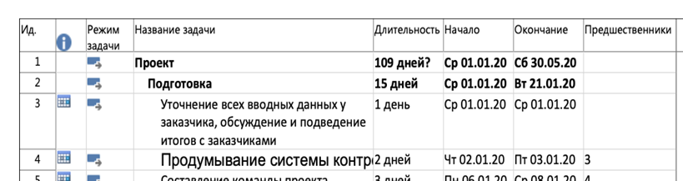Next, The definition of the project name: Menu > File > Properties. In the "Properties" window, enter the name of the project, in our case: Creating a new product (in the picture instead of "Project")

Figure 7 - Creating a new project in MS Project 2016

The next step is to determine such project parameters as the project start date and the choice of the planning method. In order to set these project parameters, go to the "Project" tab, to the "Properties" section and click on the "Project Information" icon. In the window "Project Information for ..." that appears, we set the start date of the project, for example, 01.01.20 (as we have in the figure), select the planning method from the start date of the project and click OK.

Next, you need to insert the project tasks. In order to create a stage (task), for example, the "Equipment" phase (instead of "Preparation"), you need to left-click once on an empty cell after the "New Product Creation" cell, then in the "Task" tab, in the "Insert" section, click on the "Task" icon. In the workspace, in the "Task name" column, instead of the "New task" text that appears, write "Equipment", in the "Duration" column, enter the duration of the work of this phase of the ISR and specify the start and end date. There are only 5 phases in our project (they are summary tasks), each of which is still divided into specific tasks (they are part of the summary tasks). These phases are highlighted in bold. On the toolbar in the "Task" tab in the "Planning" section, click on the "Lower task level" icon. After that, the font of the summary task will become bold, and the group of non-Изображение выглядит как стол
summary tasks will shift to the right (as in the picture).

Figure 8 - Building an ISR project in MS Project 2016

Using the example of our project, we will analyze one phase - "Equipment", allocate a duration of 15 days for it, the start date is 01.01.2020, and the end date is 21.01.2020. Next, we describe the operations of this phase: purchase, installation and commissioning, now we give each operation a start and end date. We do the same with the other phases and operations. An example is shown below.

Figure 9 - Introduction of project duration in MS Project 2016

In order to determine the total duration at the initial stage of project planning, it is necessary to establish dependencies (links) between the stages. There are four types of interrelations of works (stages): "End-Beginning" - the subsequent operation cannot begin earlier than the previous one ends; "End-End" - the subsequent operation must end no later than the previous one; "Beginning-Beginning" - the subsequent operation begins no earlier than the beginning of the preceding one; "Beginning-Ending" - the subsequent operation ends no earlier than the beginning of the preceding one. The most commonly used connections are of the type "Ending-Beginning", the most rarely - "Beginning-Ending". This is how it will look in the program:

Figure 10 - Building relationships between project activities in MS Project 2016

Filling in the "Predecessors" column.

A "predecessor" is a task that must be completed before the next task is started, which, in turn, is called a "Follower". The information shown in the "Predecessors" column is used in the work to indicate resource and frontal relationships. This column indicates the identification number of the previous task. If there are several predecessors, then the identification numbers are specified in any order and separated by ";". The identification numbers of only the immediate predecessors are indicated. Using the example of our project and the "Equipment" phase, we will describe the operations according to the predecessors: The purchase is the first operation (column 3 in the picture), after it installation (its predecessor turns out to be 3), and then commissioning (its predecessor turns out to be 4). We do the same with the other phases and operations.

Figure 11 - Setting precedence relationships for project work in MS Project 2016

Filling in the "Labor intensity" column

We use the table "Work packages" from the source data. We enter in the "Labor intensity" column the values of the labor intensity of the work complexes in man-days. Note that the column "Labor costs" cannot be created, because the program will count them anyway, only without output to the screen. To open the "Resource Assignment" window, you can use another in a way. To do this, hover the mouse pointer over the required task and right-click. In the context menu that appears, select the "Assign resources ..." command. In the "Resource Assignment" window, in the "Resource Name" column, click twice with the left mouse button on an empty cell, the "Resource Information" window opens. In the "Resource Information" window, enter the following data: "Resource name" - for example, Workers of different professions; "Type" - select the value "Labor" from the drop-down list. Click the "OK" button. This is how it will look like:

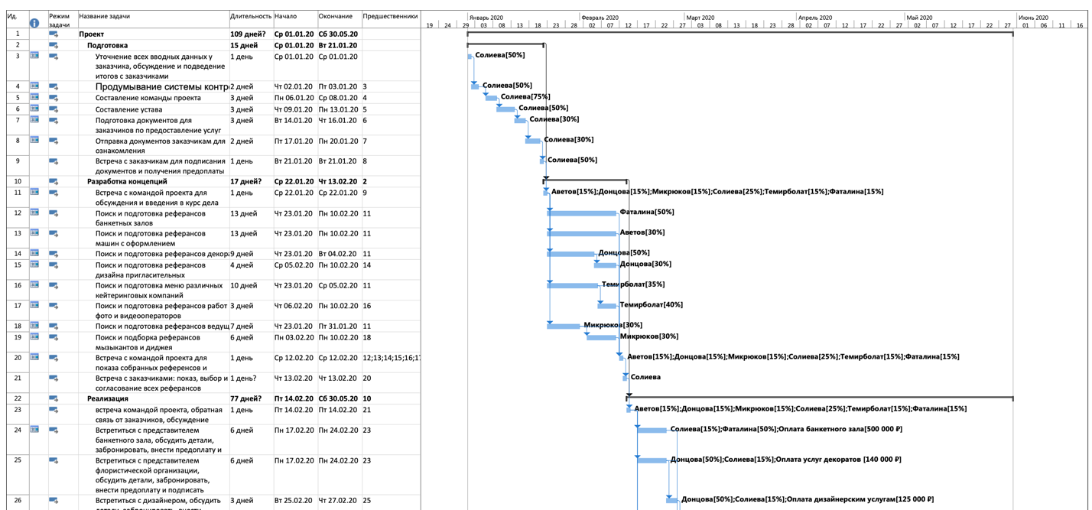

Figure 12 - Project calendar plan in MS Project 2016

Determination of the duration of work on the object

The student does not fill in the "Duration" column manually. This column is filled in automatically by means of MS Project.

Paragraph 3.3 Development of the project budget

In the ninth section of the course project, it is necessary:

Make a list of the necessary equipment for the implementation of the project,

Calculate the annual wage fund,

Calculate the planned cost of raw materials and supplies.

The project budget must be calculated based on the cost of each of the works that make up the project, since being a component of the project, the sum of the cost of all the works will indicate the necessary amount of money for the implementation of the project, that is, the budget.

Before carrying out a cost assessment, it is necessary to develop: an ISR, a responsibility matrix, calculate the sequence and duration of work.

Several methods of calculating the cost of the project are proposed:

1. Evaluation by analogs
2. Parametric estimation
3. Evaluation by three points
4. Analogous estimate method;

The method is used in cases when there is insufficient information or documentation about the project.

In order to evaluate the current project, a project similar to it or projects completed in the past is taken. Of course, a greater degree of efficiency will be achieved if your current project is evaluated by the same people who were involved in previous similar projects.

1. Parametric estimate

In essence, this method is very similar to the previous one. But in some cases it gives more accuracy due to the fact that the whole project is divided into parts. In turn, the parts directly affecting the project that can be measured are determined.

As in the case of the analogous method, there is also an emphasis on information and data from previous projects. It is important to determine which part of the change can affect the project, and then carefully study it.

The difference from the analogous method is that this method has statistical data that can be relied upon for evaluation.

1. 3-point estimate

You can also find Project Evaluation and Review Technique, abbreviated PERT. Here, as well as in the following technique, the Work Breakdown Structure is used, which implies a breakdown into smaller tasks. The manager and his team then assess them and determine the risks.

The name "3 points" consists of the evaluation method. There is a better course of events, which is called optimistic (O), the most likely (M) and the worst - pessimistic (P). Obviously, M has the greatest weight.

3 formulas can be used for evaluation.

Simplified: (O+M+Z)/3

Most accurate: (O+4M+P)/6

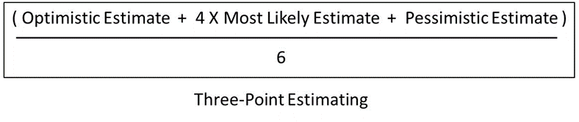Showing standard deviations: (P-O)/6.

The methods described above are widely used in project evaluation. For the best results, it is desirable to master all the techniques.

APPENDIX No. 1

Application form for fixing the topic of the course project

To the Head of the Department

**______________________________________________**

(Name)

**______________________________________________**

(Surname, initials)

From the student(s) of the ___ course, study group No. _

Faculty_______________________________________

(Name)

**_________________________________________**

(Surname, initials)

Contact details: **_________________________________**

Tel. mobile: **____________________________________**

E-mail:**________________________________________**

Statement

Please assign the topic of the course project to me

«____________________________________________________________________ ____________________________________________________________________»

«__» ___________202__. Signature ________________________

(Surname, initials)

APPENDIX No. 2

**LIST OF PERFORMERS**

|  |  |  |
| --- | --- | --- |
| Student's full name | Signature, date | Executed parts of the project |
| Student's full name | Signature, date | Executed parts of the project |
| Student's full name | Signature, date | Executed parts of the project |

APPENDIX No. 3

Sample feedback from the course project manager

Federal State Educational Budgetary Institution

of Higher Education

"FINANCIAL UNIVERSITY UNDER THE GOVERNMENT

OF THE RUSSIAN FEDERATION"

Management Department

FEEDBACK FROM THE COURSE PROJECT MANAGER

Student __________________________________________ Group___________

Topic: ____________________________________________________________

__________________________________________________________________

Course Project Manager: _____________________________________________

|  |  |  |  |  |  |  |  |  |  |
| --- | --- | --- | --- | --- | --- | --- | --- | --- | --- |
| Evaluation criteria | | Content of evaluation criteria | | | | | | Score Max. | Score Min. |
|  |  |  |  |  |  |  |  |  |  |
| The structure of the course project | | *The course project should be divided into chapters (chapters and paragraphs); contain an introduction, conclusion, list of sources used, appendices (if any)* | | | | | | **2** |  |
| Compliance of the introduction and conclusion of the course project with the established requirements | | *The introduction and conclusion must comply with the requirements provided by the Guidelines* | | | | | | **10** |  |
| Completeness and consistency of the disclosure of the topic | | The course project should logically and consistently disclose all the main issues of the topic | | | | | | **20** |  |
|  | | | | | |
|  | | | | |  |
| Independence of writing a course project | | *The course project should be written by the student independently, the use of materials from economic literature and regulatory legal acts should be formalized with references* | | | | | | **15** |  |
| Availability of the author's analysis and conclusions | | *In the course project, an analysis of the main issues of the topic should be carried out (including using actual data), conclusions are drawn* | | | | | | **20** |  |
| Compliance of the course project with regulatory legal acts | | *The course project should reflect the student's knowledge of regulatory legal acts on the topic under consideration; it should not contain errors in the use of terminology* | | | | | | **20** |  |
| Reflection of foreign and (or) historical experience | | *The course project should contain a description of foreign and (or) historical experience, an assessment of the possibility of its use by the Russian Federation* | | | | | | **5** |  |
| Scientific style of presentation | | *The use of conversational or journalistic style is not allowed in the course project* | | | | | | **3** |  |
| Correctness of the design | | *The course project should be designed in accordance with the requirements provided by the Guidelines* | | | | | | **5** |  |
| Total points (on a 100-point scale) | |  | | | | | | **100** |  |
| Total points (on a 5  -point scale) | | *86-100 - "excellent" (5);*  *70-85 - "good" (4);*  *50-69 - "satisfactory" (3);*  *less than 50 – "unsatisfactory" (2)* | | | | | |  |  |

APPENDIX No. 4

**Samples of bibliographic descriptions of printed works in the literature lists**

**Samples of bibliographic descriptions of documents in the references**

1. **Description of a book by one author**

Nikiforova N. A. Complex economic analysis: textbook. for example, Bachelor's degree in Economics and Management / N. A. Nikiforova; Financial University. - Moscow: Knorus, 2021— - 439 p— - (Bachelor's degree).

Shitov V.N. History of finance of Russia: studies. manual for university students, teaching. in the specialty "Finance and Credit", e.g. "Economics" (qualification. (degree) "bachelor") / V.N. Shitov. - 3rd ed., erased. - Moscow: Knorus, 2020. - 156 p— - (Bachelor's degree).

1. **Description of the book by 2, 3 authors**

Perskaya V.V. Integration in conditions of multipolarity. Evolution of the theory and practice of implementation = Integration processes amid multipolarity. Evolution of theory and practice of implementation: monograph / Perskaya V.V., Eskindarov M.A. - Moscow: Ekonomika, 2016. - 383 p.

Valishin E.N. Theory and practice of human resource management: textbook. manual / E.N. Valishin, I.A. Ivanova, V.N. Pulyaeva; Financial University. - Moscow: Rusains, 2020. - 127 p.

Rose P.S. Bank Management & Financial Services / P. S. Rose, S. Hudgins. — 8-th ed. — Boston : Mc Graw Hill, 2010. — 734 p.

3. **Description of the book by 4 authors**

History of Russia: textbook / A.S. Orlov, V.A. Georgiev, N.G. Georgieva, T. A. Sivokhina; Lomonosov Moscow State University. - 4th ed., reprint. and add. - Moscow: Prospect, 2020. - 528 p.

IELTS Foundation: Student's Book. CEF Levels B1-B2 / Andrew Preshous, Rachael Roberts, Joanna Preshous, Joanne Gakonga— - 2nd ed. - Oxford: Macmillan Publishers Limited, 2014. - 176 p. — (Macmillan Exams).

4**. Description of the book by 5 or more authors**

Modern architecture of finance in Russia: monograph / M.A. Eskindarov, V.V. Maslennikov, M.A. Abramova [et al.]; edited by M.A. Eskindarov, V.V. Maslennikov; Financial University. - Moscow: Kogito-Center, 2020. - 487 p.

One hundred years of development. 1919-2019 / author-comp.: Ya.A. Plais, S.L. Anokhina, T.A. Miroshnikova [et al.]; under the general editorship of M.A. Eskindarov; Financial University at The Government of the Russian Federation. - Moscow: International Relations, 2019— - 696 p.

1. **Description of collections**

Collection of scientific articles of the V International Scientific Conference "Institutional Economics: development, teaching, applications", November 15, 2017 - Moscow: GUU, 2017. - 382 p.

Collection of selected articles by young Scientists / Institute of Economics of the Russian Academy of Sciences; edited by I.A. Boldyrev, M.Y. Golovnin, R.S. Grinberg. - Moscow: Ekonomika, 2010. - 288 p. - (Library of the New Economic Association /editorial series: V.M. Polterovich, M.A. Eskindarov, B.M. Smitienko [et al.]).

1. **Description of articles from newspapers, magazines and collections**

Chetverikov V.M. Features and intensity of the spread of COVID-19 in large economies // Questions of statistics. - 2020. - No. 6. - pp. 86-104.

Batalova A. Let the financial elite. More than 400 schoolchildren became winners and prize-winners of the Olympiad "Mission is feasible!" / Batalova A., Duel A. // Rossiyskaya Gazeta. - 2020. - March 5. — № 48. — C. 10.

Rykova I.N. Assessment of creditworthiness of oil and gas industry companies in modern conditions of development of banking activity / I. N. Rykova, D. Yu. Taburov, A.V. Borisova // Banking. - 2019. - No. 12. - pp. 41-50.

Pivovarova M. A. Cluster initiatives: general and special / M. A. Pivovarova // Cluster initiatives in the formation of a progressive structure of the national economy : collection of scientific tr. of the 2nd International Scientific and Practical Conference (March 17-18, 2016). Vol.1 / South-Western State University; rel. edited by A.A. Gorokhov. - Kursk, 2016. - pp. 173-177.

Morozko N.I. (Morozko N.I.) Business management strategy based on value-oriented concepts / Morozko N. I. (Morozko N.I.), Didenko V. Y. (Didenko V.Yu.) // The Strategies of Modern Science Development: Proceedings of the X International scientific-practical conference (North Charleston, USA, 12-13 April 2016). — USA, North Charleston, 2016. — P. 79-81.

7. **Description of regulatory legal acts**

Budget Code of the Russian Federation: as of February 20, 2019 : comparative table of changes. - Moscow: Prospekt, 2019. - 368 p.

On the general principles of the organization of local self-government in the Russian Federation: Feder. Law No. 131-FZ: [adopted by the State Duma on September 16, 2003: approved by the Federation Council on September 24, 2003]. - Moscow: Prospect; St. Petersburg: Codex, 2017. - 158 p.

On Amendments to the Federal Law "On Special Assessment of Working Conditions": Feder. the law of 27 Dec. 2019 No. 451-FZ: adopted By the State Duma on 17 Dec. 2019: Approved by the Federation Council on Dec 23. 2019 // Rossiyskaya Gazeta. - 2019. - Dec 30. - No. 295. - S. 14.

About education in the Russian Federation: Feder. the law of 29 Dec. 2012 No. 273-FZ: [adopted by the State Duma on Dec. 2012: Approved by the Federation Council on 26 Dec. 2012] // Collection of legislation of the Russian Federation. - 2012. - 31 Dec. - No. 53. - St. 7598.

GOST R 57564-2017. Organization and implementation of work on international standardization in the Russian Federation = Organization and implementation of activity on international standardization in the Russian Federation: ed. ofits.: approved and put into effect by Order of the Federal Agency for Technical Regulation and Metrology dated July 28, 2017 No. 767-st : date of introduction 2017-12-01 / developed by the All-Russian Scientific Research. institute of Standardization and Certification in Mechanical Engineering (VNIINMASH). - Moscow: Standartinform, 2017. - V, 44 p.

8. **Description of dissertations, abstracts of dissertations, deposited manuscripts**

Slavin B.B. Theoretical foundations and instrumental support of collective intelligence technologies in organization management: dis. ... Doctor of Economics; spec. 08.00.13; protected 17.06.2020; approved 23.06.2020 / B.B. Slavin; Place of protection: Financial University; Work done: Financial University, Department of Data Analysis. - Moscow, 2020. - 342 p. : ill.

Velichkovsky B. B. Functional organization of working memory: abstract. diss... doct. psychological sciences: spec. 19.00.01 "General psychology, personality psychology, history of psychology" / Velichkovsky B. B.; Moscow State University named after M. V. Lomonosov; Place of defense: Institute of Psychology of the Russian Academy of Sciences. - Moscow, 2017. - 44 p.

Labyntsev N.T. Professional and public accreditation and independent assessment of qualifications in the field of personnel training and accounting activities / N.T. Labyntsev, E.A. Sharovatova; Rostov State Economic University. un-t (RINH). - Rostov-on-Don, 2017. - 305 p. - Dept. in VINITI RAS 10.01.2017 No. 1-B2017.

9. **Description of disks and other local access resources**

Eriashvili N. D. Banking law: electron. studies. for university students / N. D. Eriashvili. - 8th ed., reprint. and an additional Electron. dan. - Moscow: UNITY-DANA, 2011– - 1 electron. opt. disk (CD-ROM). - Cover from the disc label.

The development of industrial production in the Siberian Federal District: stat. sat. / Feder. state service. statistics, Territory. Feder organs. state services. statistics. - Electron. dan. - Omsk, 2012– - 1 electron. opt. disk (CD-ROM). - Plug from the container.

10. **Description of electronic resources of network distribution**

1. Vesnin V.R. Fundamentals of management: textbook / V. R. Vesnin. - Moscow: Prospekt, 2016. - 500 p. - EBS Prospekt. - URL: http://ezpro.fa.ru:3180/book/23323 (accessed: 19.01.2021). - Text: electronic.

2. Salin V.N. Banking statistics : textbook. and a workshop for universities / V.N. Salin, O.G. Tretyakova. - Moscow: Yurayt, 2020— - 215 p— - (Higher education). - ABS Urite. - URL: https://ezpro.fa.ru:3217/bcode/450266 (accessed: 18.01.2021). - Text: electronic.

3. Adhiry B. K. Crowdfunding: Lessons from Japan’s Approach / Bishnu Kumar Adhiry, Kenji Kutsuna, Takaaki Hoda; Kobe University Social Science Research Series. - Singapore : Springer Ltd., 2018. - 110 p. - SpringerLink. - URL: https://link.springer.com/chapter/10.1007/978-981-13-1522-0_7 (date of application: 10.12.2020). - The text is electronic.

4. The Russian socio-economic system: realities and vectors of development: monograph / P. V. Savchenko, R. S. Grinberg, M. A. Abramova [et al.] ; ed. by R. S. Grinberg, P. V. Savchenko— - 3rd ed., reprint. and add. - 3rd ed. - Moscow: INFRA-M, 2019. - 598 p. - (Scientific thought). - ABS Znanium.com . - URL: https://new.znanium.com/catalog/product/961584 (date of application: 10.12.2020). - Text: electronic.

5. Dadashev A.Z. On the issue of financial independence of municipalities and methods of assessing its level / A.Z. Dadashev, A.I. Zolotko. - Text: electronic // Finance and Credit. - 2018. - No. 9. - pp. 2017-2032— - NEB eLibrary. - URL: https://www.elibrary.ru/download/elibrary_35648256_50368935.pdf (date of application: 10.12.2020).

6. Conjunctural analysis of the practice of implementing professional standards in Russia in 2018 / A.A. Tsyganov, A.S. Ermolaeva, S.V. Brovchak, E.V. Bogdanova. - Text: electronic // Prospects of science and education. - 2019. - No. 5. - pp. 517-528— - EB of the Financial University. — URL: https://pnojournal.files.wordpress.com/2019/11/pdf_190537.pdf. - Date of publication: 31.10.2019.

1. http://www.tehnochoc.ru/price.html
2. https://mosenergosbyt.info/tarify/