104 группа
Английский язык
Задания по грамматике
1.Задайте общие вопросы по образцу.
Образец:
There are some roses in the vase. Are there any roses in the vase? There is some wine in the glass. Is there any wine in the glass?
1. There are some letters for Ann. 2. There is some noise (шум) in the corridor. 3. There are some children in the garden. 4. There are some cars in the street. 5. There is some fish in the fridge. 6. There is some ice-cream on the table. 7. There are some books on the shelf. 8. There are some old shoes under the bed.
2. Измените предложения по образцу, употребляя отрицательное местоимение no.
Образец:
There aren't any boys there. There are no boys there.
1. There isn't any coffee in the cup. 2. There aren't any students in the class-room. 3. There aren't any cars in the street. 4. He hasn't any friends. 5. They haven't any money. 6. We haven't any meat for supper. 7. That country hasn't any coffee to export.
3. Вставьте some или any.
1. There are … students in the library. 2. There isn't … light in the room. 3. Mary has got two sisters but she hasn't got … brothers. 4. I don't like popular music but … people like it. 5. Has Mother … meat for dinner? – Yes, she has … . 6. Are there … mistakes in Nick's dictation? – No, there are not … . 7. Has Max … friends here? – Yes, he has … . 8. Has Bess … interesting books to read? – No, she hasn't … . 9. Would you like … coffee? 10. Can I have … tea, please?

Задания по лексике
1. Соотнеси:
A living room | a room for bathing
A drawing room | a room for sleeping
A dining room | a room for special use of children
A bedroom | a room for general use during the day
A bathroom | a room used for cooking
A kitchen | a number of rooms on one floor of a house
A study | a room for having meals
A flat | a room used for studying
A nursery | a room for receiving guests

2. Прочитайте текст и определите, какая из трех предложенных комнат (A, B or C) описана ниже:
It is a very beautiful living-room. There is a big sofa and 2 arm-chairs. In the middle of the room there is a small table with some magazines on it. If we look to the right, we can see a large window, so the room is very light. There is also a carpet on the floor which makes the room cosy. On the wall there is a picture and there is a vase next to it. The walls and the ceiling are white and it makes the room look bigger.
Picture A
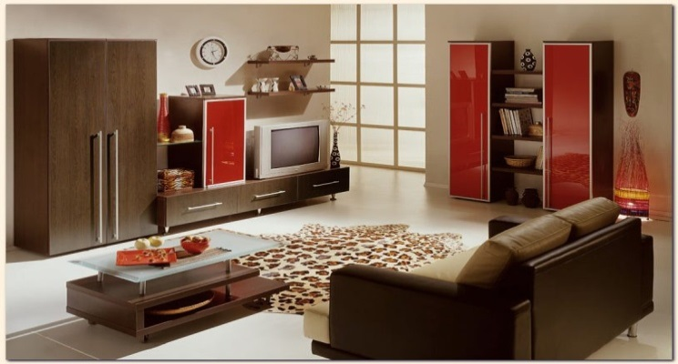

Picture B
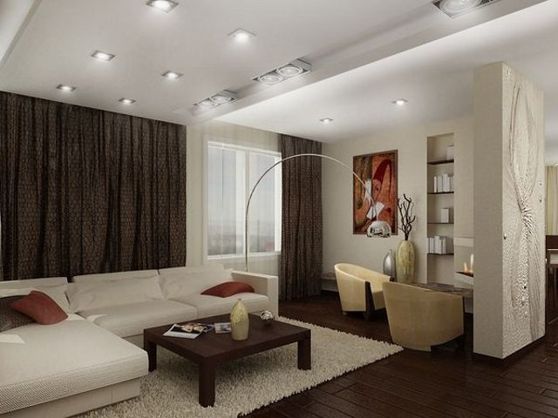

Picture C
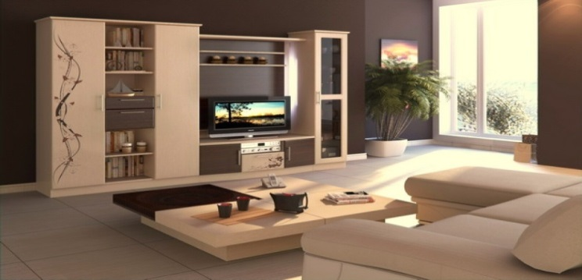

История
Е-mail: NVAnufrieva@fa.ru
Тема: Цивилизации древнего мира
Домашнее задание
1. Ознакомьтесь с материалом презентации «Цивилизации древнего мира».
2. Составьте сравнительную таблицу по Древнему Египту, Китаю, Древней Греции и Риму.
.
Работу выполнить в программе Microsoft World. Отправлять на проверку не нужно. Подготовиться к проверке таблицы на занятии.

Требования к оформлению и срокам выполнения.
Выполненное задание – схему, необходимо подготовить в срок до 27 января 2022 года. Задание должно быть выполнено печатно (электронно) в программе MS World. По запросу преподавателя документ необходимо будет загрузить на сервер в ходе занятия.

